fintech_wallet | SBP
V1.0

Revision History
Version | Date | Description | Author
1.0 | 17/02/2026 | Initial Version | Mohammed Megahed

Reviewers
# | Name | Position | Date and Signature
1
2

Acceptance and Signoff
# | Name | Position | Date and Signature
1
2

Contents
1. Introduction 5
1.1. Project Summary 5
1.2. In-Scope 5
1.3. Out-Scope 5
1.4. Target Audience 5
1.5. Abbreviations 5
1.6. Assumptions, Dependencies and Risks 5
1.7. Impact Questionnaire 6
2. Requirements Compliancy Matrix 6
3. Solution Architecture 7
3.1. Solution Description 7
3.2. Non-Functional Requirements 8
3.3. Security Considerations 8
4. User Registration and KYC Flow 9
4.1. Sequence Diagram 9
4.2. Flow Description 10
4.3. State Machine Diagram 12
4.4. APIs Contract Agreement 13
4.5. Error Handling 14
5. Wallet Top-up via Card Payment 17
5.1. Sequence Diagram 17
5.2. Flow Description 17
5.3. State Machine Diagram 20
5.4. APIs Contract Agreement 22
5.5. Error Handling 23
6. Peer-to-Peer Fund Transfer 26
6.1. Sequence Diagram 26
6.2. Flow Description 27
6.3. State Machine Diagram 30
6.4. APIs Contract Agreement 32
6.5. Error Handling 33
7. Bill Payment via SADAD 35
7.1. Sequence Diagram 35
7.2. Flow Description 36
7.3. State Machine Diagram 38
7.4. APIs Contract Agreement 40
7.5. Error Handling 41
8. Appendix 44
8.1. User Registration and KYC Flow Data Elements 44
8.2. Wallet Top-up via Card Payment Data Elements 45
8.3. Peer-to-Peer Fund Transfer Data Elements 46
8.4. Bill Payment via SADAD Data Elements 47
8.5. Solution Architecture Reference Documents 48

1. Introduction

1.1. Project Summary
FinWallet is a digital wallet platform that addresses the need for secure, compliant digital payments by enabling users to register, complete KYC using national ID and selfie capture, and manage multi-currency wallets (SAR, USD, AED). Key capabilities include mobile OTP registration, sanctions screening, P2P transfers to other users, and domestic bank transfers via SARIE. This solution streamlines onboarding and provides users with flexible, compliant payment options.

1.2. In-Scope
# | Item
1. | User registration with mobile OTP verification
2. | KYC verification via national ID and selfie capture
3. | Multi-currency wallet creation and management (SAR, USD, AED)
4. | P2P transfers to other FinWallet users
5. | Domestic bank transfers via SARIE
6. | Bill payments via SADAD integration
7. | Wallet top-up via card and Apple Pay

1.3. Out-Scope
# | Item
1. | International remittances via SWIFT
2. | Physical card issuance
3. | Merchant onboarding and management
4. | Cryptocurrency transactions

1.4. Target Audience
# | Stakeholders
1. | Enterprise Architects
2. | Partners and Vendors Technical Leaders
3. | Infrastructure Architects & Engineers
4. | InfoSec Architects & Engineers
5. | Technical Managers
6. | Delivery Leads and Project Managers
7. | Developers

1.5. Abbreviations
# | Abbreviations | Full form
1

1.6. Assumptions, Dependencies and Risks
# | Item | Type | Owner | Comment
1.
2.

2. Requirements Compliancy Matrix
ID. | Title | Description | Compliancy | Comments
FR-1 | FinWallet is a comprehensive digital wallet platform enabling users to store fun | FinWallet allows users to securely store funds, make payments, and transfer money using mobile and web applications, providing a convenient and accessible digital wallet experience. | Compliant
FR-2 | The platform supports multi-currency wallets, P2P transfers, bill payments, and | The platform enables users to manage multiple currencies, send money to peers, pay bills, and make payments to merchants using QR codes, providing flexible and convenient financial services. | Compliant
FR-3 | Integration with national ID verification (Elm Yakeen) ensures KYC compliance | The business verifies customer identities using the national ID verification service to meet Know Your Customer (KYC) compliance requirements. This ensures only legitimate customers can access services and supports regulatory adherence. | Compliant
FR-BR-001 | User Registration | Users can create an account to access the system’s services and features. This ensures only authorized individuals use the platform and enables personalized user experiences. | Compliant
FR-BR-002 | apture | The business captures and verifies customer identification information to meet Know Your Customer (KYC) regulatory requirements and prevent financial crime. | Compliant
FR-BR-003 | erification | The business verifies the identity of customers to ensure they are who they claim to be and to prevent fraud. | Compliant
FR-BR-004 | Sanctions Screening | All customers, transactions, and counterparties are screened against current sanctions lists to prevent prohibited or restricted activity and ensure compliance with regulatory requirements. | Compliant
FR-BR-005 | Wallet Creation | Users can create a digital wallet to securely store and manage their digital assets. This enables users to access wallet services and perform transactions as needed. | Compliant
FR-BR-006 | Multi-Currency | The solution supports transactions and reporting in multiple currencies, allowing users to conduct business and view financial information in their preferred currency. This enables accurate financial management and compliance in international operations. | Compliant
FR-BR-007 | Balance Display | Users can view their current account balance at any time to make informed financial decisions and monitor their funds. | Compliant
FR-BR-008 | P2P Transfer | Users can send and receive funds directly to and from other individuals, enabling fast and convenient peer-to-peer payments. | Compliant
FR-BR-009 | Bank Transfer | The system enables users to transfer funds securely and efficiently between bank accounts, supporting timely payments and financial transactions. | Compliant
FR-BR-010 | Bill Payment | Customers can pay their bills quickly and securely through the platform, ensuring timely payments and improved customer satisfaction. | Compliant

3. Solution Architecture

3.1. Solution Description
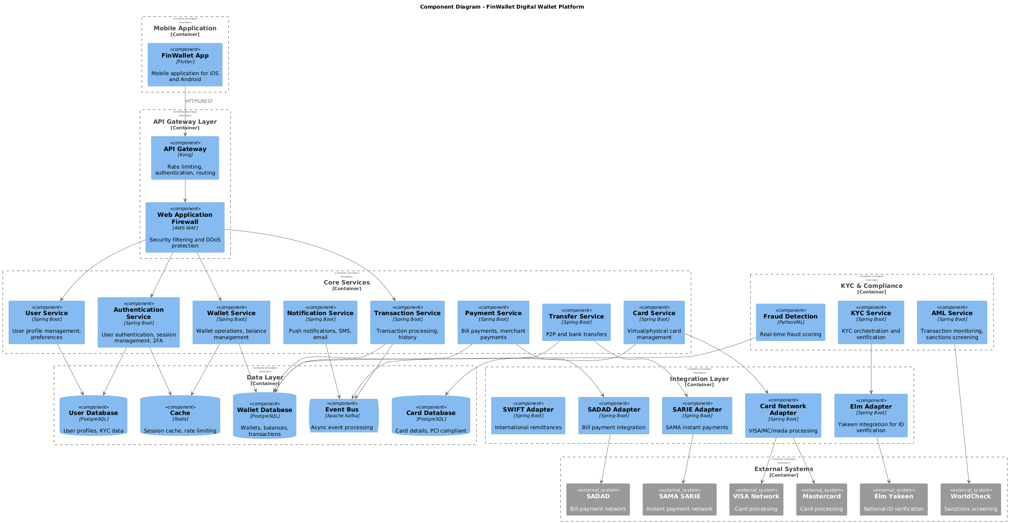

3.2. Non-Functional Requirements
# | Category | Requirement | Target/SLA
1 | Performance | API Response Time | < 2 seconds for 95th percentile
2 | Performance | Transaction Throughput | Support 100 TPS during peak hours
3 | Availability | System Uptime | 99.9% availability (excluding planned maintenance)
4 | Availability | Recovery Time Objective (RTO) | < 4 hours
5 | Availability | Recovery Point Objective (RPO) | < 1 hour
6 | Scalability | Horizontal Scaling | Support auto-scaling based on load
7 | Scalability | Concurrent Users | Support 1000 concurrent users
8 | Data Retention | Transaction Logs | Retain for 7 years as per regulatory requirements
9 | Data Retention | Audit Logs | Retain for 5 years
10 | Compliance | Regulatory | Comply with CMA and SAMA regulations
11 | Compliance | Data Protection | Comply with data privacy requirements

3.3. Security Considerations
# | Security Domain | Requirement | Implementation
1 | Authentication | User Authentication | OAuth 2.0 / JWT tokens with secure token storage
2 | Authentication | Service-to-Service Auth | Mutual TLS (mTLS) for internal service communication
3 | Authentication | Multi-Factor Authentication | MFA required for sensitive operations
4 | Authorization | Role-Based Access Control | RBAC implemented with principle of least privilege
5 | Authorization | API Authorization | Scope-based access control for API endpoints
6 | Data Protection | Data in Transit | TLS 1.2+ encryption for all network communication
7 | Data Protection | Data at Rest | AES-256 encryption for sensitive data storage
8 | Data Protection | PII/Sensitive Data | Data masking and tokenization for sensitive fields
9 | API Security | Input Validation | Server-side validation of all input parameters
10 | API Security | Rate Limiting | Rate limiting to prevent abuse and DDoS attacks
11 | API Security | CORS Policy | Strict CORS policy for web API endpoints
12 | Audit & Logging | Audit Trail | Log all security-relevant events with timestamps
13 | Audit & Logging | Log Protection | Immutable logs with tamper detection
14 | Vulnerability Management | Security Scanning | Regular SAST/DAST scanning in CI/CD pipeline
15 | Vulnerability Management | Dependency Scanning | Automated scanning for vulnerable dependencies

4. User Registration and KYC Flow

4.1. Sequence Diagram
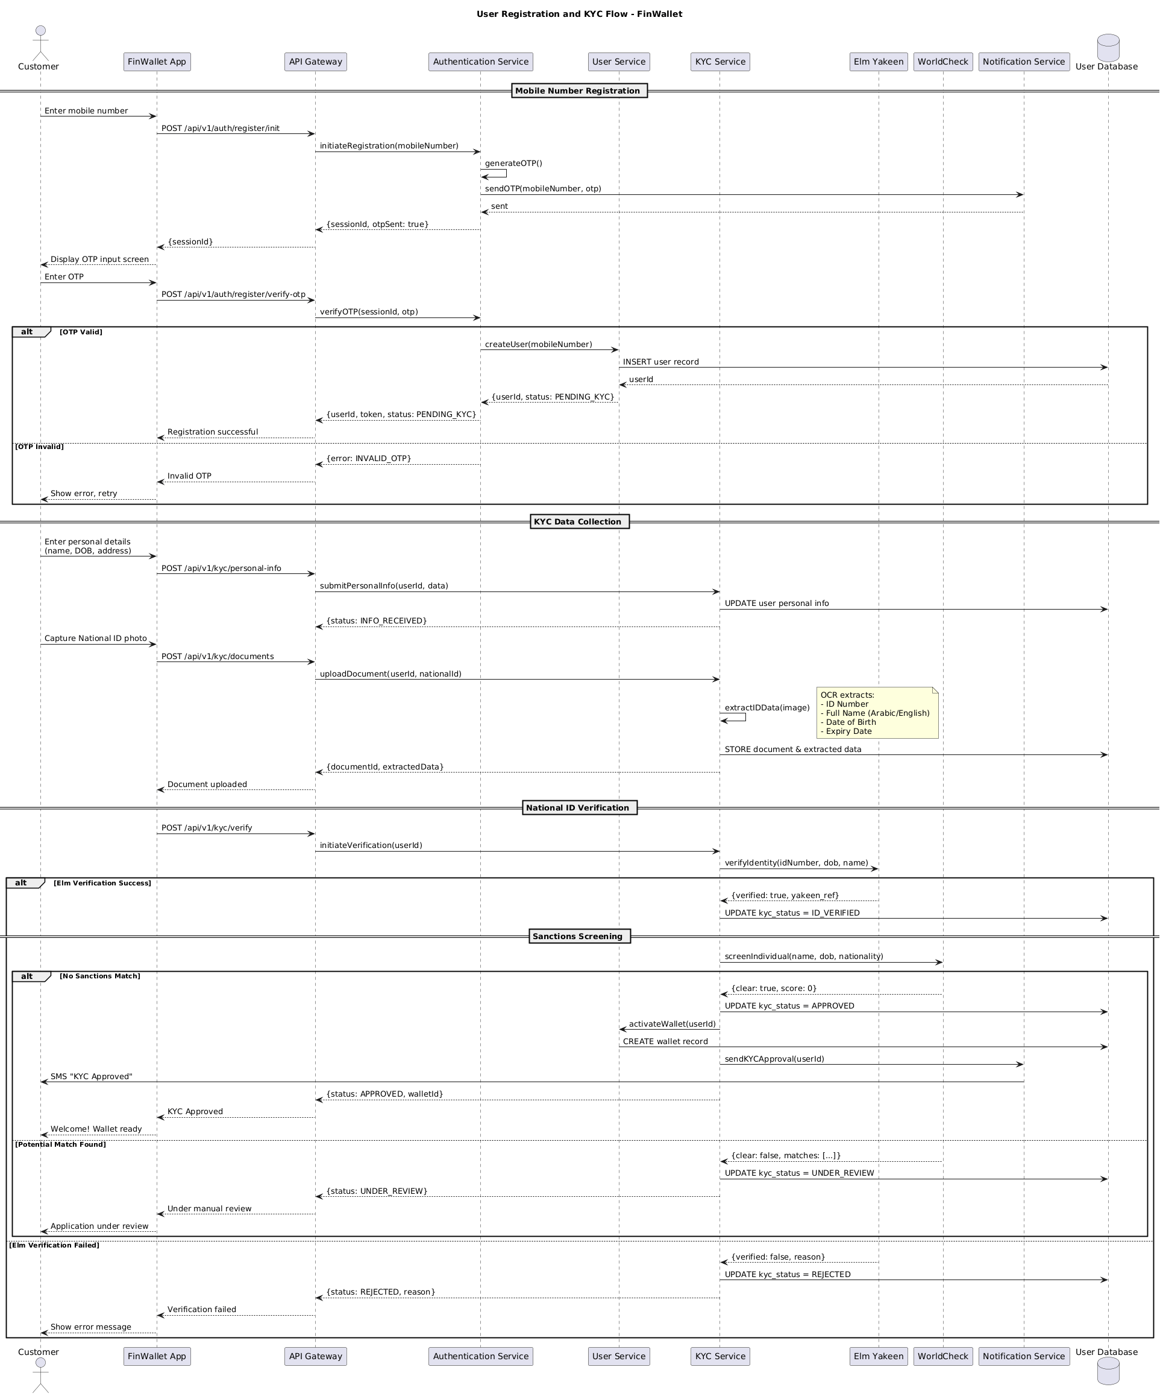

4.2. Flow Description
  - Overview
This flow describes the end-to-end user onboarding and KYC (Know Your Customer) process for the FinWallet platform. It covers mobile number registration, OTP verification, personal information and document collection, national ID verification through external systems, sanctions screening, and final wallet activation or review. The flow involves the following active participants: Customer, FinWallet App, API Gateway, Authentication Service, User Service, KYC Service, Elm Yakeen, WorldCheck, Notification Service, and User Database. Each participant is responsible for specific steps in the registration, validation, and approval process.
  - Process Flow
Mobile Number Registration
The process begins when Customer enters their mobile number into FinWallet App. The FinWallet App sends a registration initiation request to API Gateway. API Gateway forwards this request to Authentication Service to initiate registration using the provided mobile number. Authentication Service internally generates an OTP. Authentication Service sends the OTP to Notification Service for delivery to the user's mobile number. Notification Service confirms the OTP has been sent. Authentication Service returns a session ID and an OTP sent status to API Gateway, which then relays the session ID back to FinWallet App. FinWallet App displays the OTP input screen to Customer.
Customer enters the OTP into FinWallet App, which submits the OTP verification request to API Gateway. API Gateway forwards the verification request to Authentication Service.
If the OTP is valid, Authentication Service requests User Service to create a new user with the provided mobile number. User Service inserts a new user record into User Database. User Database returns the generated user ID to User Service. User Service responds to Authentication Service with the user ID and a status of PENDING_KYC. Authentication Service returns the user ID, an authentication token, and the PENDING_KYC status to API Gateway. API Gateway notifies FinWallet App that registration was successful.
If the OTP is invalid, Authentication Service returns an INVALID_OTP error to API Gateway. API Gateway informs FinWallet App of the invalid OTP. FinWallet App displays an error message to Customer and prompts for a retry.
KYC Data Collection
Customer provides personal details, including name, date of birth, and address, to FinWallet App. FinWallet App submits this information to API Gateway, which relays it to KYC Service. KYC Service updates the user's personal information in User Database. KYC Service confirms receipt of the information to API Gateway, which notifies FinWallet App.
Customer then captures a photo of their national ID using FinWallet App. The app uploads the document to API Gateway, which forwards it to KYC Service. KYC Service internally performs extraction of ID data from the image.
Note: OCR extracts:
- ID Number
- Full Name (Arabic/English)
- Date of Birth
- Expiry Date
KYC Service stores the document and extracted data in User Database. KYC Service returns the document ID and extracted data to API Gateway, which notifies FinWallet App that the document has been uploaded.
National ID Verification
FinWallet App initiates the verification of the uploaded national ID by sending a request to API Gateway. API Gateway forwards this request to KYC Service. KYC Service initiates identity verification with Elm Yakeen, providing the extracted ID number, date of birth, and name.
If Elm Yakeen verifies the identity successfully, it returns a positive verification result and a reference to KYC Service. KYC Service updates the KYC status to ID_VERIFIED in User Database.
Sanctions Screening
After successful identity verification, KYC Service screens the individual against sanctions lists by sending the user's name, date of birth, and nationality to WorldCheck.
If WorldCheck finds no sanctions match, it returns a clear status and a score of zero to KYC Service. KYC Service updates the KYC status to APPROVED in User Database. KYC Service instructs User Service to activate the user's wallet. User Service creates a wallet record in User Database. KYC Service sends a KYC approval notification to Notification Service. Notification Service sends an SMS to Customer indicating KYC approval. KYC Service returns the approved status and wallet ID to API Gateway, which notifies FinWallet App. FinWallet App welcomes Customer and confirms the wallet is ready.
If WorldCheck finds a potential sanctions match, it returns a non-clear status and match details to KYC Service. KYC Service updates the KYC status to UNDER_REVIEW in User Database. KYC Service returns the UNDER_REVIEW status to API Gateway, which notifies FinWallet App. FinWallet App informs Customer that the application is under manual review.
If Elm Yakeen fails to verify the identity, it returns a negative verification result and a reason to KYC Service. KYC Service updates the KYC status to REJECTED in User Database. KYC Service returns the rejected status and reason to API Gateway, which notifies FinWallet App. FinWallet App displays an error message to Customer.
  - Authentication & Validation
Authentication Service internally generates the OTP during registration initiation. KYC Service internally extracts ID data from the uploaded national ID image. These internal operations are critical for secure authentication and accurate data extraction during the onboarding process.

4.3. State Machine Diagram
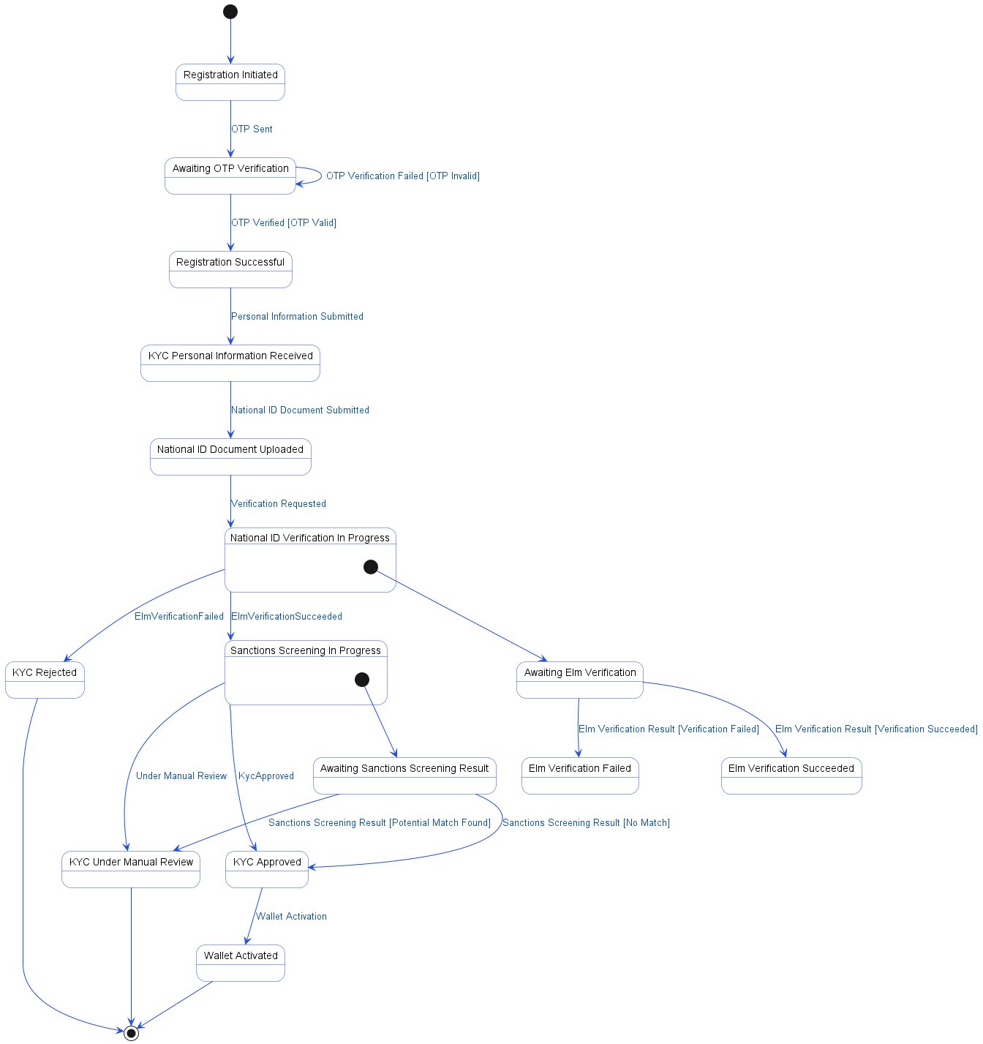

4.4. APIs Contract Agreement
# | Source | Destination | API | Protocol | Request Parameters | Response Parameters
1 | FinWallet App | API Gateway | POST /api/v1/auth/register/init | REST |  | {sessionId}
2 | API Gateway | Authentication Service | initiateRegistration | REST | mobileNumber | {sessionId, otpSent: true}
3 | Authentication Service | Notification Service | sendOTP | REST | mobileNumber, otp | sent
4 | FinWallet App | API Gateway | POST /api/v1/auth/register/verify-otp | REST |  | Registration successful
5 | API Gateway | Authentication Service | verifyOTP | REST | sessionId, otp | {userId, token, status: PENDING_KYC}
6 | Authentication Service | User Service | createUser | REST | mobileNumber | {userId, status: PENDING_KYC}
7 | FinWallet App | API Gateway | POST /api/v1/kyc/personal-info | REST |  | Document uploaded
8 | API Gateway | KYC Service | submitPersonalInfo | REST | userId, data | {status: INFO_RECEIVED}
9 | KYC Service | User Database | UPDATE user personal info | JDBC
10 | FinWallet App | API Gateway | POST /api/v1/kyc/documents | REST |  | KYC Approved
11 | API Gateway | KYC Service | uploadDocument | REST | userId, nationalId | {documentId, extractedData}
12 | KYC Service | User Database | STORE document & extracted data | JDBC
13 | FinWallet App | API Gateway | POST /api/v1/kyc/verify | REST |  | Under manual review
14 | API Gateway | KYC Service | initiateVerification | REST | userId | {status: APPROVED, walletId}
15 | KYC Service | Elm Yakeen | verifyIdentity | REST | idNumber, dob, name | {verified: true, yakeen_ref}
16 | KYC Service | User Database | UPDATE kyc_status = ID_VERIFIED | JDBC
17 | KYC Service | WorldCheck | screenIndividual | REST | name, dob, nationality | {clear: true, score: 0}
18 | KYC Service | User Database | UPDATE kyc_status = APPROVED | JDBC
19 | KYC Service | User Service | activateWallet | REST | userId
20 | KYC Service | Notification Service | sendKYCApproval | REST | userId
21 | Notification Service | Customer | SMS "KYC Approved" | REST
22 | KYC Service | User Database | UPDATE kyc_status = UNDER_REVIEW | JDBC
23 | KYC Service | User Database | UPDATE kyc_status = REJECTED | JDBC
[*] Indicates that the data element is optional

4.5. Error Handling
# | Source | Destination | Scenario | Handling
1 | API Gateway | Authentication Service | initiateRegistration  Timeout waiting for Authentication Service to respond | Retry up to 3 times with exponential backoff; Log error with correlation ID for traceability; Return error code to upstream caller
2 | Authentication Service | Notification Service | sendOTP  Notification Service unavailable or not reachable | Retry up to 3 times with exponential backoff; Log error with correlation ID for traceability; Return error code to upstream caller
3 | Authentication Service | User Service | createUser  Timeout waiting for User Service to respond | Ensure idempotency to avoid duplicates on retry; Retry up to 3 times with exponential backoff; Log error with correlation ID for traceability; Return error code to upstream caller
4 | Authentication Service | User Service | createUser  Duplicate request for same mobile number | Ensure idempotency to avoid duplicates on retry; Log error with correlation ID for traceability; Return error code to upstream caller
5 | Authentication Service | User Service | createUser  Validation failure due to invalid or missing data | Ensure idempotency to avoid duplicates on retry; Log error with correlation ID for traceability; Return error code to upstream caller
6 | API Gateway | KYC Service | submitPersonalInfo  Timeout waiting for KYC Service to respond | Retry up to 3 times with exponential backoff; Log error with correlation ID for traceability; Return error code to upstream caller
7 | API Gateway | KYC Service | submitPersonalInfo  Validation failure due to incomplete or invalid personal information | Log error with correlation ID for traceability; Return error code to upstream caller
8 | API Gateway | KYC Service | uploadDocument  Timeout waiting for KYC Service to respond | Retry up to 3 times with exponential backoff; Log error with correlation ID for traceability; Return error code to upstream caller
9 | API Gateway | KYC Service | uploadDocument  Validation failure due to unsupported or unreadable document | Log error with correlation ID for traceability; Return error code to upstream caller
10 | API Gateway | KYC Service | initiateVerification  Timeout waiting for KYC Service to respond | Retry up to 3 times with exponential backoff; Log error with correlation ID for traceability; Return error code to upstream caller
11 | KYC Service | Elm Yakeen | verifyIdentity  Timeout waiting for Elm Yakeen to respond | Retry up to 3 times with exponential backoff; Log error with correlation ID for traceability; Activate circuit breaker, use fallback response
12 | KYC Service | Elm Yakeen | verifyIdentity  Elm Yakeen service unavailable | Retry up to 3 times with exponential backoff; Log error with correlation ID for traceability; Activate circuit breaker, use fallback response; Notify operations team via alert if repeated
13 | KYC Service | Elm Yakeen | verifyIdentity  Data not found for provided ID number | Log error with correlation ID for traceability; Return error code to upstream caller
14 | KYC Service | WorldCheck | screenIndividual  Timeout waiting for WorldCheck to respond | Retry up to 3 times with exponential backoff; Log error with correlation ID for traceability; Activate circuit breaker, use fallback response
15 | KYC Service | WorldCheck | screenIndividual  WorldCheck service unavailable | Retry up to 3 times with exponential backoff; Log error with correlation ID for traceability; Activate circuit breaker, use fallback response; Notify operations team via alert if repeated
16 | KYC Service | WorldCheck | screenIndividual  Data not found for individual screening | Log error with correlation ID for traceability; Return error code to upstream caller
17 | KYC Service | User Service | activateWallet  Timeout waiting for User Service to respond | Ensure idempotency to avoid duplicates on retry; Retry up to 3 times with exponential backoff; Log error with correlation ID for traceability; Return error code to upstream caller
18 | KYC Service | User Service | activateWallet  Duplicate request for same userId | Ensure idempotency to avoid duplicates on retry; Log error with correlation ID for traceability; Return error code to upstream caller
19 | KYC Service | User Service | activateWallet  Validation failure due to user not eligible | Ensure idempotency to avoid duplicates on retry; Log error with correlation ID for traceability; Return error code to upstream caller
20 | KYC Service | Notification Service | sendKYCApproval  Notification Service unavailable or not reachable | Retry up to 3 times with exponential backoff; Log error with correlation ID for traceability; Queue request for asynchronous retry
21 | KYC Service | Notification Service | sendKYCApproval  Timeout waiting for Notification Service to respond | Retry up to 3 times with exponential backoff; Log error with correlation ID for traceability; Queue request for asynchronous retry

5. Wallet Top-up via Card Payment

5.1. Sequence Diagram
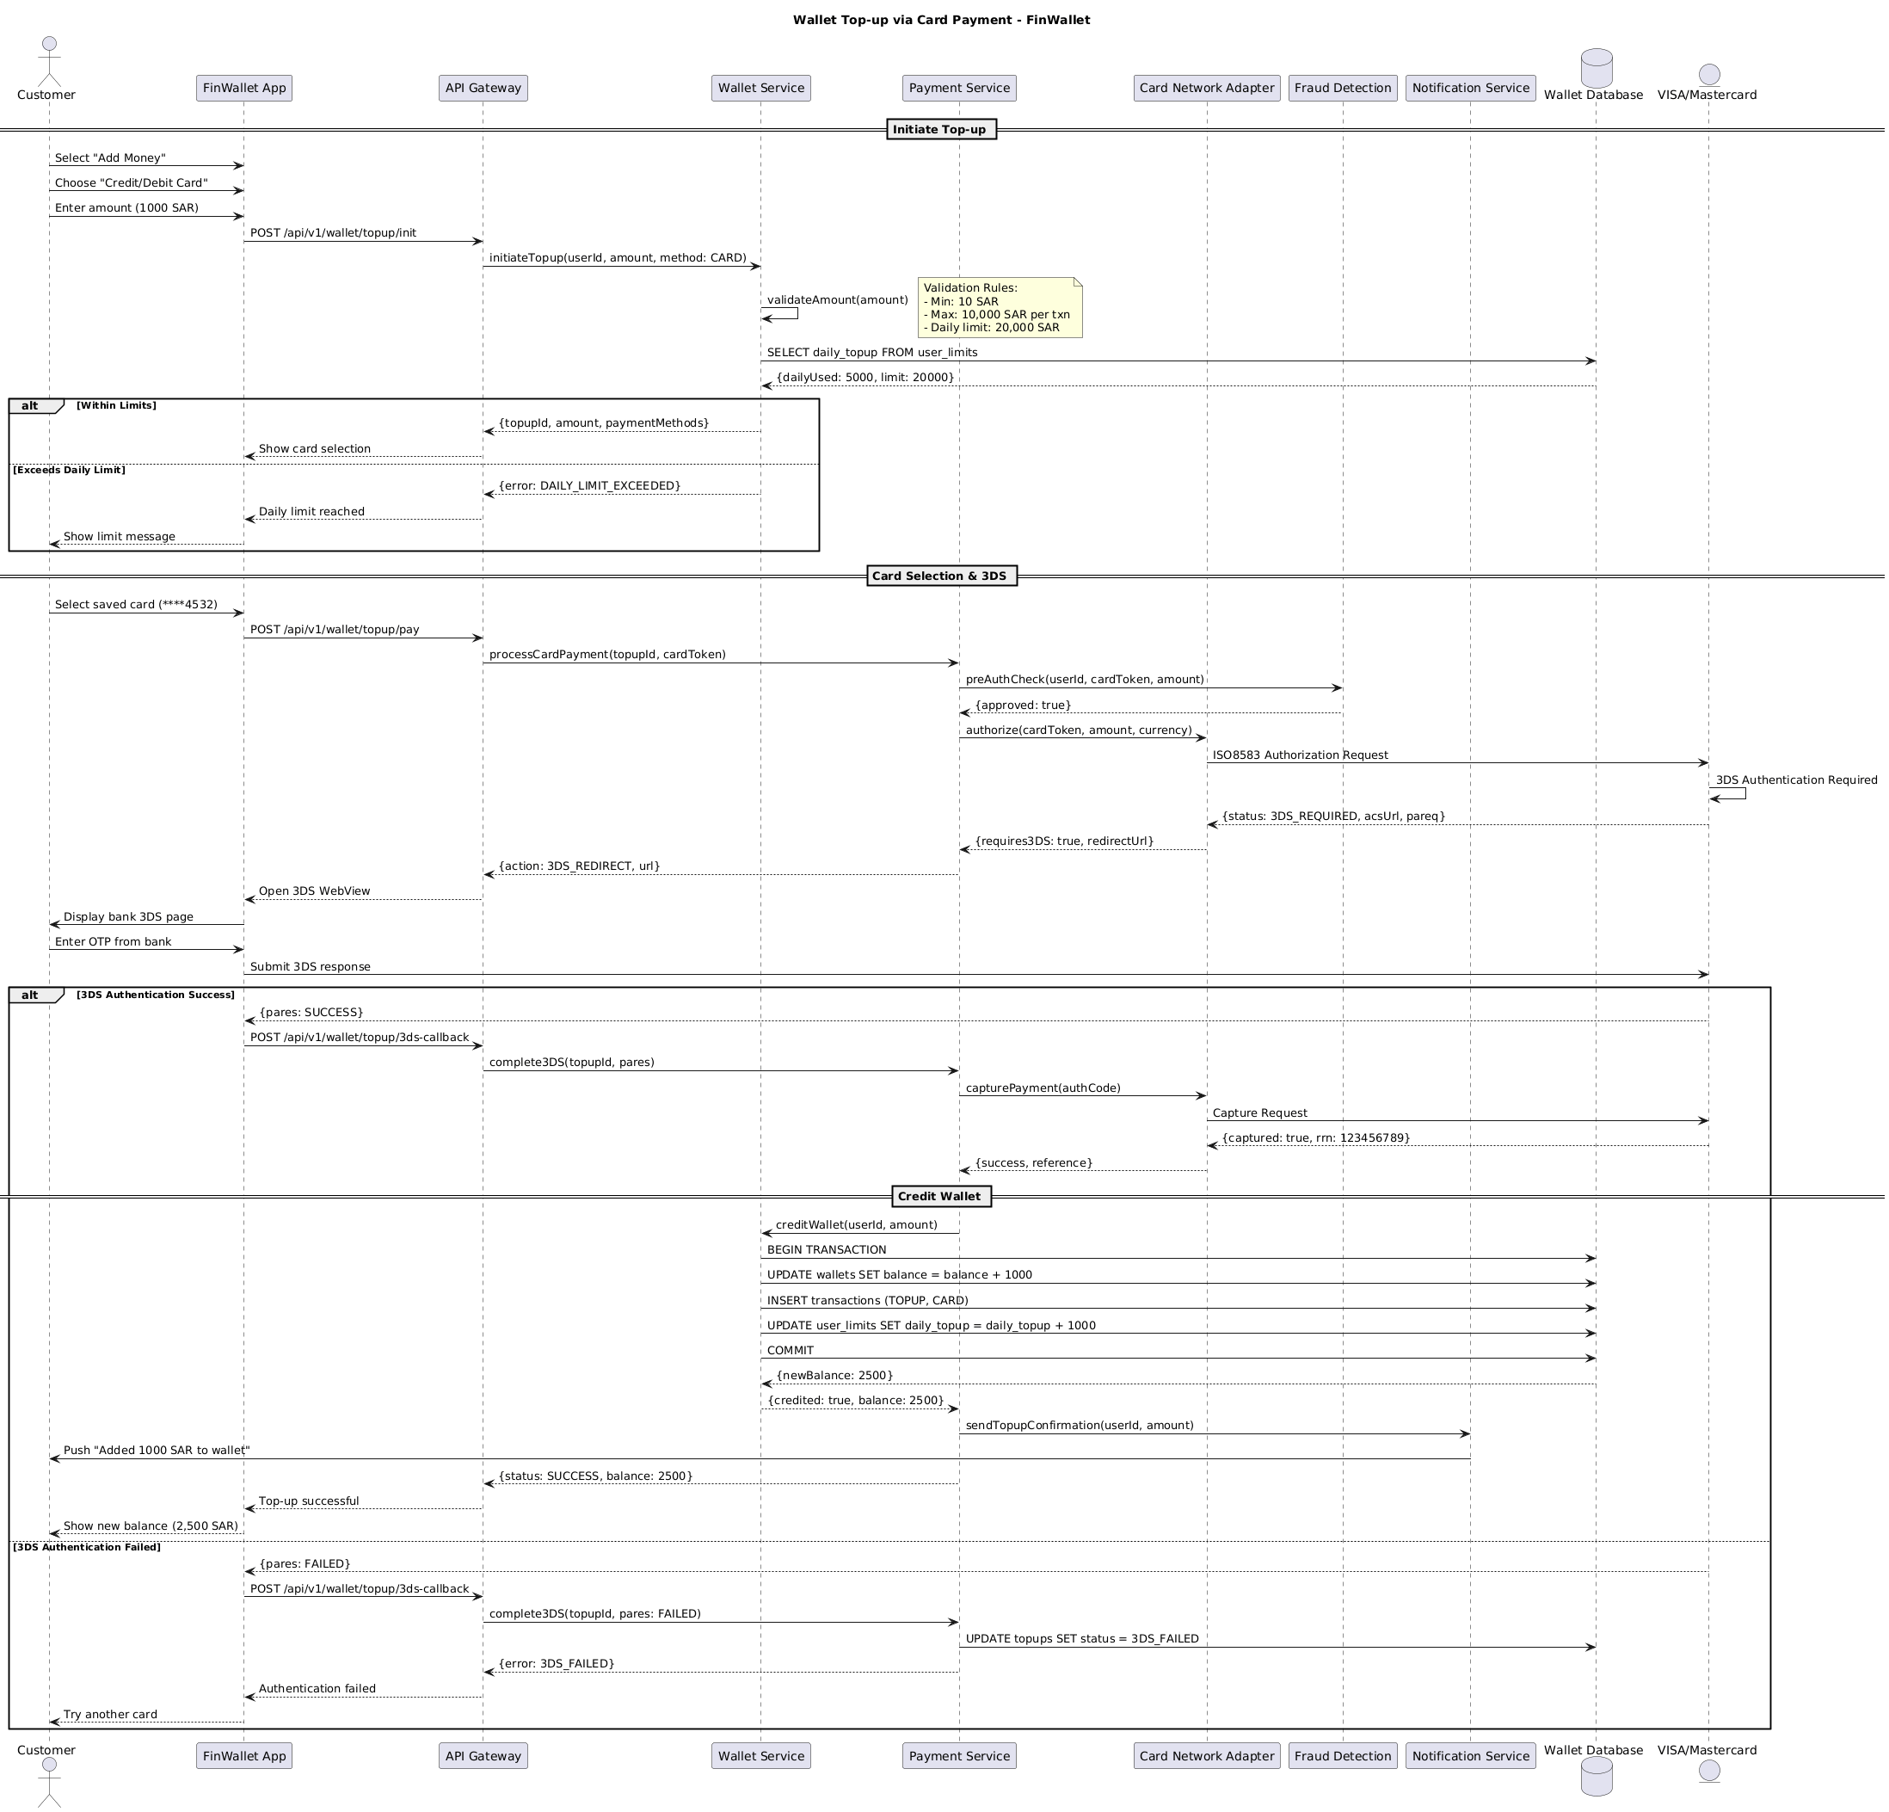

5.2. Flow Description
  - Overview
This flow describes the end-to-end process for a wallet top-up via card payment within the FinWallet platform. The flow involves the following actively participating components: Customer, FinWallet App, API Gateway, Wallet Service, Wallet Database, Payment Service, Fraud Detection, Card Network Adapter, VISA/Mastercard, and Notification Service. The process covers user initiation, validation of limits, card selection, 3D Secure (3DS) authentication, payment capture, wallet crediting, and notification delivery. All interactions, internal operations, and conditional branches are explicitly detailed as they occur in the flow.
  - Process Flow
Initiate Top-up
Customer begins the process by selecting "Add Money" in FinWallet App. Customer then chooses "Credit/Debit Card" as the funding method and enters an amount of 1000 SAR.
FinWallet App sends a request to API Gateway to initiate the top-up by calling the endpoint POST /api/v1/wallet/topup/init. API Gateway forwards this request to Wallet Service with the parameters userId, amount, and method set to CARD.
Wallet Service internally validates the amount provided.
Note: Validation Rules:
- Min: 10 SAR
- Max: 10,000 SAR per txn
- Daily limit: 20,000 SAR
Wallet Service queries Wallet Database to retrieve the user's daily top-up usage and limit. Wallet Database responds with the current daily usage and the allowed daily limit.
If the requested top-up amount is within the allowed limits, Wallet Service returns a response to API Gateway containing the topupId, amount, and available payment methods. API Gateway then instructs FinWallet App to display the card selection interface.
If the requested amount exceeds the daily limit, Wallet Service responds to API Gateway with an error indicating DAILY_LIMIT_EXCEEDED. API Gateway informs FinWallet App that the daily limit has been reached, and FinWallet App notifies Customer by displaying a message about the exceeded limit.
Card Selection & 3DS
Assuming the top-up is within limits, Customer selects a saved card (for example, ****4532) in FinWallet App. FinWallet App sends a payment request to API Gateway via POST /api/v1/wallet/topup/pay. API Gateway forwards this to Payment Service to process the card payment, passing the topupId and cardToken.
Payment Service initiates a pre-authorization fraud check by calling Fraud Detection with the userId, cardToken, and amount. Fraud Detection responds with approval.
Payment Service requests authorization from Card Network Adapter using the cardToken, amount, and currency. Card Network Adapter sends an ISO8583 Authorization Request to VISA/Mastercard.
VISA/Mastercard internally performs 3DS Authentication Required.
VISA/Mastercard returns a response to Card Network Adapter indicating that 3DS authentication is required, along with the acsUrl and pareq. Card Network Adapter informs Payment Service that 3DS is required and provides a redirect URL. Payment Service instructs API Gateway to initiate a 3DS redirect, passing the URL. API Gateway tells FinWallet App to open the 3DS WebView.
FinWallet App displays the bank's 3DS authentication page to Customer. Customer enters the OTP received from the bank. FinWallet App submits the 3DS response to VISA/Mastercard.
If 3DS authentication is successful, VISA/Mastercard responds to FinWallet App with pares: SUCCESS. FinWallet App notifies API Gateway by calling POST /api/v1/wallet/topup/3ds-callback. API Gateway forwards the callback to Payment Service to complete the 3DS process with the topupId and pares.
Payment Service requests Card Network Adapter to capture the payment using the authorization code. Card Network Adapter sends a Capture Request to VISA/Mastercard. VISA/Mastercard responds to Card Network Adapter confirming the capture, including the retrieval reference number. Card Network Adapter informs Payment Service of the successful capture and provides a reference.
Credit Wallet
Payment Service requests Wallet Service to credit the user's wallet with the specified amount. Wallet Service initiates a transaction with Wallet Database by beginning a transaction, updating the wallet balance by adding 1000 SAR, inserting a record into the transactions table for the top-up via card, updating the user's daily top-up usage, and committing the transaction. Wallet Database returns the new wallet balance to Wallet Service. Wallet Service confirms to Payment Service that the wallet has been credited and provides the updated balance.
Payment Service instructs Notification Service to send a top-up confirmation to the user. Notification Service pushes a notification to Customer indicating that 1000 SAR has been added to the wallet.
Payment Service informs API Gateway of the successful top-up and the new balance. API Gateway notifies FinWallet App that the top-up was successful. FinWallet App displays the new balance of 2,500 SAR to Customer.
If 3DS authentication fails, VISA/Mastercard responds to FinWallet App with pares: FAILED. FinWallet App notifies API Gateway via the 3ds-callback endpoint. API Gateway instructs Payment Service to complete the 3DS process with the failed pares status. Payment Service updates Wallet Database to set the top-up status to 3DS_FAILED. Payment Service informs API Gateway of the 3DS failure. API Gateway notifies FinWallet App that authentication failed. FinWallet App prompts Customer to try another card.
  - Authentication & Validation
Wallet Service internally validates the top-up amount to ensure compliance with minimum, maximum, and daily limit rules.
Note: Validation Rules:
- Min: 10 SAR
- Max: 10,000 SAR per txn
- Daily limit: 20,000 SAR
VISA/Mastercard internally performs 3DS Authentication Required as part of the card authorization process.

5.3. State Machine Diagram
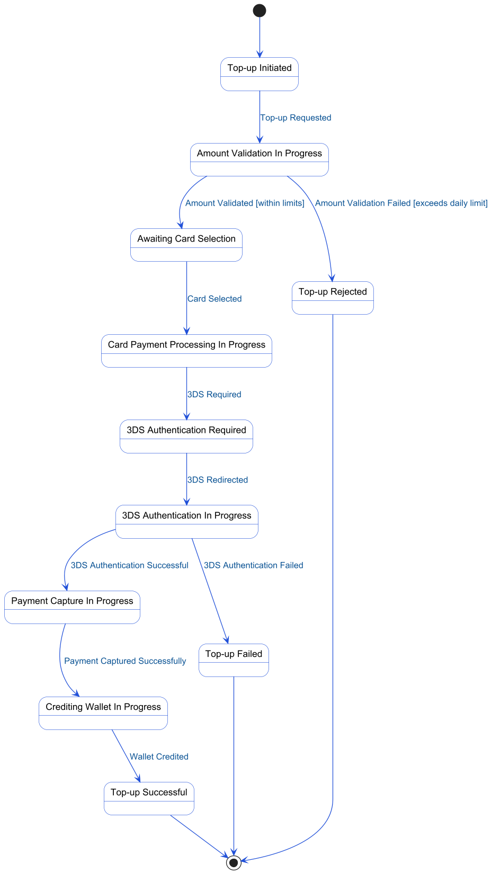

5.4. APIs Contract Agreement
# | Source | Destination | API | Protocol | Request Parameters | Response Parameters
1 | FinWallet App | API Gateway | POST /api/v1/wallet/topup/init | REST |  | Show card selection
2 | API Gateway | Wallet Service | initiateTopup | REST | userId, amount, method: CARD | {topupId, amount, paymentMethods}
3 | Wallet Service | Wallet Database | SELECT daily_topup FROM user_limits | JDBC |  | {dailyUsed: 5000, limit: 20000}
4 | FinWallet App | API Gateway | POST /api/v1/wallet/topup/pay | REST |  | Open 3DS WebView
5 | API Gateway | Payment Service | processCardPayment | REST | topupId, cardToken | {action: 3DS_REDIRECT, url}
6 | Payment Service | Fraud Detection | preAuthCheck | REST | userId, cardToken, amount | {approved: true}
7 | Payment Service | Card Network Adapter | authorize | REST | cardToken, amount, currency | {requires3DS: true, redirectUrl}
8 | Card Network Adapter | VISA/Mastercard | ISO8583 Authorization Request | REST |  | {status: 3DS_REQUIRED, acsUrl, pareq}
9 | FinWallet App | Customer | Display bank 3DS page | REST
10 | FinWallet App | VISA/Mastercard | Submit 3DS response | REST |  | {pares: SUCCESS}
11 | FinWallet App | API Gateway | POST /api/v1/wallet/topup/3ds-callback | REST |  | Top-up successful
12 | API Gateway | Payment Service | complete3DS | REST | topupId, pares | {status: SUCCESS, balance: 2500}
13 | Payment Service | Card Network Adapter | capturePayment | REST | authCode | {success, reference}
14 | Card Network Adapter | VISA/Mastercard | Capture Request | REST |  | {captured: true, rrn: 123456789}
15 | Payment Service | Wallet Service | creditWallet | REST | userId, amount | {credited: true, balance: 2500}
16 | Wallet Service | Wallet Database | BEGIN TRANSACTION | JDBC |  | {newBalance: 2500}
17 | Wallet Service | Wallet Database | UPDATE wallets SET balance = balance + 1000 | JDBC
18 | Wallet Service | Wallet Database | INSERT transactions | JDBC | TOPUP, CARD
19 | Wallet Service | Wallet Database | UPDATE user_limits SET daily_topup = daily_topup + 1000 | JDBC
20 | Wallet Service | Wallet Database | COMMIT | JDBC
21 | Payment Service | Notification Service | sendTopupConfirmation | REST | userId, amount
22 | Notification Service | Customer | Push "Added 1000 SAR to wallet" | REST
23 | FinWallet App | API Gateway | POST /api/v1/wallet/topup/3ds-callback | REST |  | Authentication failed
24 | API Gateway | Payment Service | complete3DS | REST | topupId, pares: FAILED | {error: 3DS_FAILED}
25 | Payment Service | Wallet Database | UPDATE topups SET status = 3DS_FAILED | JDBC
[*] Indicates that the data element is optional

5.5. Error Handling
# | Source | Destination | Scenario | Handling
1 | API Gateway | Wallet Service | initiateTopup  Timeout waiting for response from Wallet Service | Retry up to 3 times with exponential backoff; Log error with correlation ID for traceability; Return error code to upstream caller
2 | API Gateway | Wallet Service | initiateTopup  Wallet Service unavailable or returns 5xx error | Retry up to 3 times with exponential backoff; Log error with correlation ID for traceability; Activate circuit breaker, use fallback response
3 | Wallet Service | Wallet Database | SELECT  Database unavailable or query timeout | Retry up to 3 times with exponential backoff; Log error with correlation ID for traceability; Return error code to upstream caller
4 | API Gateway | Wallet Service | initiateTopup  Data not found for given userId | Log error with correlation ID for traceability; Return error code to upstream caller
5 | API Gateway | Payment Service | processCardPayment  Timeout waiting for response from Payment Service | Retry up to 3 times with exponential backoff; Log error with correlation ID for traceability; Return error code to upstream caller
6 | API Gateway | Payment Service | processCardPayment  Payment Service unavailable or returns 5xx error | Retry up to 3 times with exponential backoff; Log error with correlation ID for traceability; Activate circuit breaker, use fallback response
7 | Payment Service | Fraud Detection | preAuthCheck  Timeout waiting for Fraud Detection response | Retry up to 3 times with exponential backoff; Log error with correlation ID for traceability; Return error code to upstream caller
8 | Payment Service | Fraud Detection | preAuthCheck  Fraud Detection service unavailable or returns 5xx error | Retry up to 3 times with exponential backoff; Log error with correlation ID for traceability; Activate circuit breaker, use fallback response
9 | Payment Service | Card Network Adapter | authorize  Timeout waiting for Card Network Adapter response | Retry up to 3 times with exponential backoff; Log error with correlation ID for traceability; Return error code to upstream caller
10 | Payment Service | Card Network Adapter | authorize  Card Network Adapter unavailable or returns 5xx error | Retry up to 3 times with exponential backoff; Log error with correlation ID for traceability; Activate circuit breaker, use fallback response
11 | Card Network Adapter | VISA/Mastercard | ISO8583 Authorization Request  Timeout waiting for VISA/Mastercard response | Retry up to 3 times with exponential backoff; Log error with correlation ID for traceability; Return error code to upstream caller
12 | Card Network Adapter | VISA/Mastercard | ISO8583 Authorization Request  VISA/Mastercard unavailable or returns error | Retry up to 3 times with exponential backoff; Log error with correlation ID for traceability; Activate circuit breaker, use fallback response
13 | API Gateway | Payment Service | complete3DS  Timeout waiting for Payment Service response | Retry up to 3 times with exponential backoff; Log error with correlation ID for traceability; Return error code to upstream caller
14 | API Gateway | Payment Service | complete3DS  Payment Service unavailable or returns 5xx error | Retry up to 3 times with exponential backoff; Log error with correlation ID for traceability; Activate circuit breaker, use fallback response
15 | Payment Service | Card Network Adapter | capturePayment  Timeout waiting for Card Network Adapter response | Retry up to 3 times with exponential backoff; Log error with correlation ID for traceability; Return error code to upstream caller
16 | Payment Service | Card Network Adapter | capturePayment  Card Network Adapter unavailable or returns 5xx error | Retry up to 3 times with exponential backoff; Log error with correlation ID for traceability; Activate circuit breaker, use fallback response
17 | Card Network Adapter | VISA/Mastercard | Capture Request  Timeout waiting for VISA/Mastercard response | Retry up to 3 times with exponential backoff; Log error with correlation ID for traceability; Return error code to upstream caller
18 | Card Network Adapter | VISA/Mastercard | Capture Request  VISA/Mastercard unavailable or returns error | Retry up to 3 times with exponential backoff; Log error with correlation ID for traceability; Activate circuit breaker, use fallback response
19 | Payment Service | Wallet Service | creditWallet  Timeout waiting for Wallet Service response | Ensure idempotency to avoid duplicates on retry; Retry up to 3 times with exponential backoff; Log error with correlation ID for traceability; Notify operations team via alert if repeated
20 | Payment Service | Wallet Service | creditWallet  Wallet Service unavailable or returns 5xx error | Ensure idempotency to avoid duplicates on retry; Retry up to 3 times with exponential backoff; Log error with correlation ID for traceability; Activate circuit breaker, use fallback response
21 | Payment Service | Wallet Service | creditWallet  Duplicate creditWallet request received | Ensure idempotency to avoid duplicates on retry; Log error with correlation ID for traceability; Return error code to upstream caller
22 | Payment Service | Wallet Service | creditWallet  Validation failure (e.g., invalid userId or amount) | Ensure idempotency to avoid duplicates on retry; Log error with correlation ID for traceability; Return error code to upstream caller
23 | Payment Service | Notification Service | sendTopupConfirmation  Timeout waiting for Notification Service response | Retry up to 3 times with exponential backoff; Log error with correlation ID for traceability; Queue request for asynchronous retry
24 | Payment Service | Notification Service | sendTopupConfirmation  Notification Service unavailable or returns 5xx error | Retry up to 3 times with exponential backoff; Log error with correlation ID for traceability; Queue request for asynchronous retry
25 | API Gateway | Wallet Service | initiateTopup  Duplicate initiateTopup request received | Ensure idempotency to avoid duplicates on retry; Log error with correlation ID for traceability; Return error code to upstream caller
26 | API Gateway | Payment Service | processCardPayment  Duplicate processCardPayment request received | Ensure idempotency to avoid duplicates on retry; Log error with correlation ID for traceability; Return error code to upstream caller
27 | API Gateway | Payment Service | complete3DS  Duplicate complete3DS request received | Ensure idempotency to avoid duplicates on retry; Log error with correlation ID for traceability; Return error code to upstream caller
28 | Payment Service | Wallet Service | creditWallet  Partial completion—balance updated but transaction not recorded | Ensure idempotency to avoid duplicates on retry; Rollback partial transaction; Log error with correlation ID for traceability; Notify operations team via alert if repeated

6. Peer-to-Peer Fund Transfer

6.1. Sequence Diagram
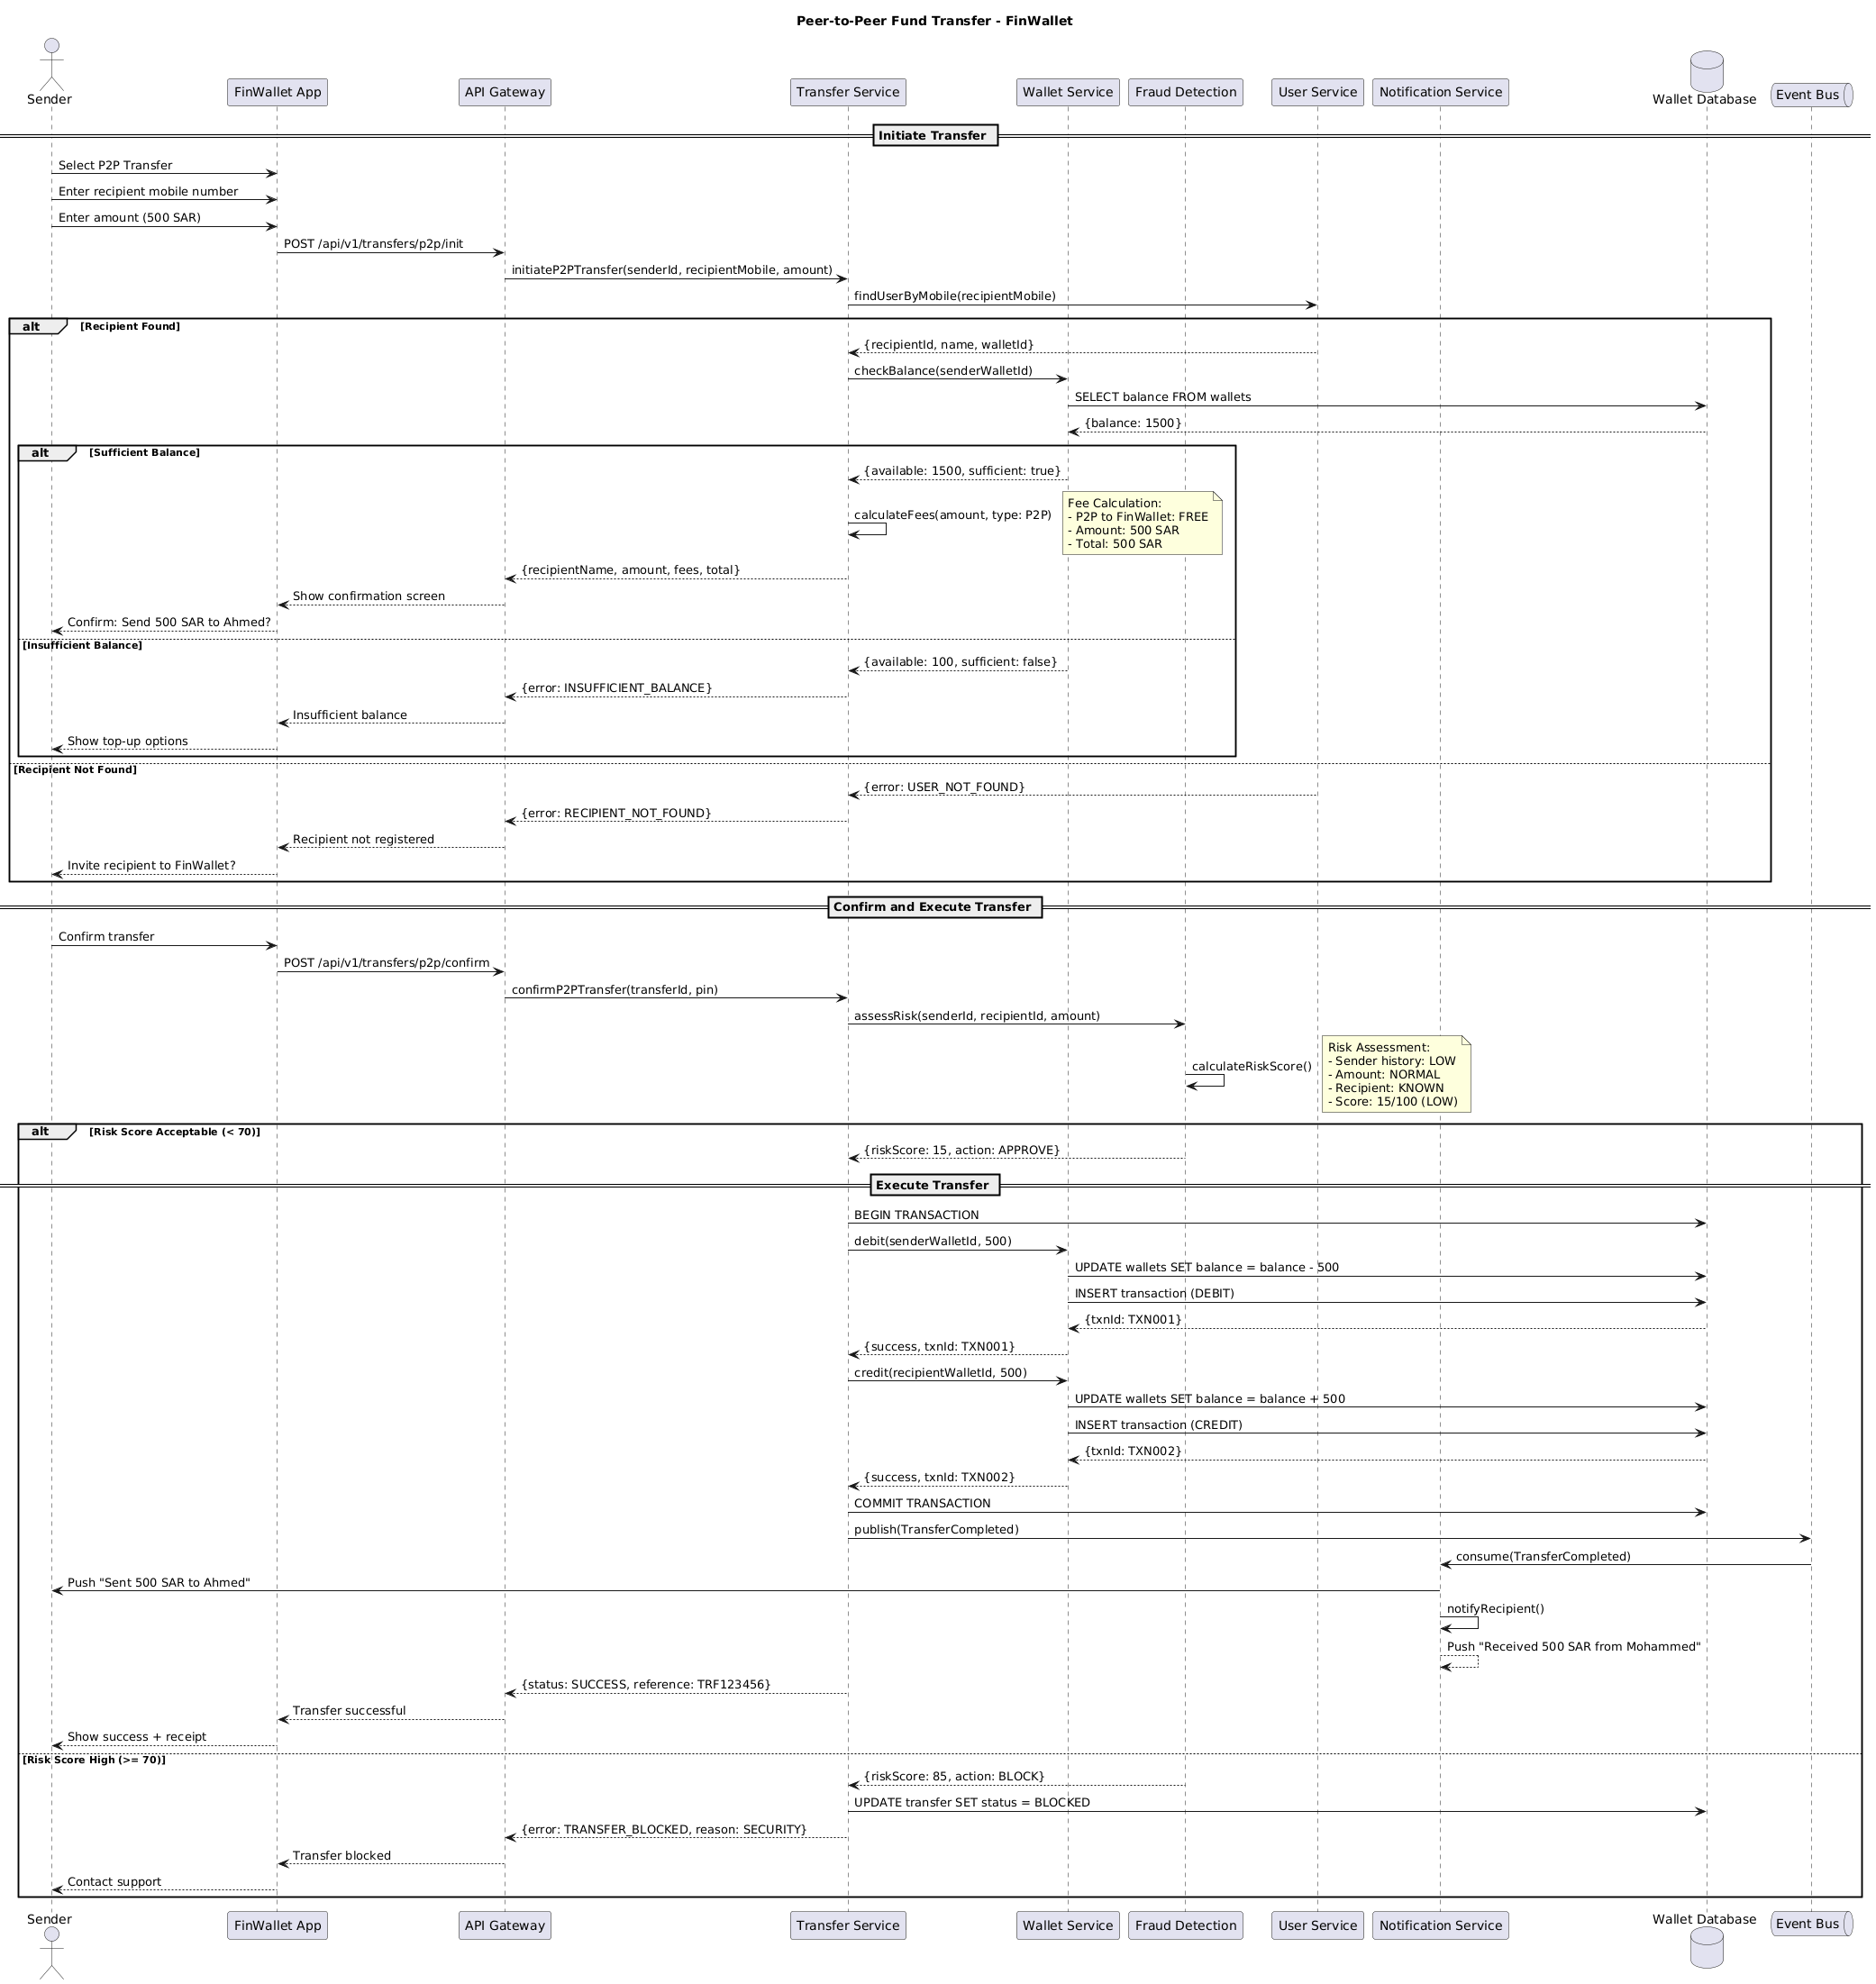

6.2. Flow Description
  - Overview
This flow details the peer-to-peer (P2P) fund transfer process within the FinWallet ecosystem. It covers the end-to-end interactions between the sender, FinWallet App, API Gateway, Transfer Service, Wallet Service, User Service, Fraud Detection, Notification Service, Wallet Database, and Event Bus. The flow includes transfer initiation, recipient validation, balance checks, fee calculation, risk assessment, transaction execution, notification delivery, and error handling. All actors and systems are referenced as they appear in the flow.
  - Process Flow
Initiate Transfer
The process begins when the sender interacts with FinWallet App to select the P2P transfer option. The sender enters the recipient's mobile number and specifies the transfer amount of 500 SAR. FinWallet App then sends a request to API Gateway to initiate the transfer, which is forwarded to Transfer Service with the sender’s ID, recipient’s mobile number, and the specified amount.
Transfer Service queries User Service to locate the recipient based on the provided mobile number. If the recipient is found, User Service returns the recipient’s ID, name, and wallet ID to Transfer Service. Transfer Service then requests Wallet Service to check the sender’s wallet balance. Wallet Service queries Wallet Database for the current balance and receives a response indicating the available funds.
If the sender’s balance is sufficient, Wallet Service confirms availability and sufficiency of funds to Transfer Service. Transfer Service internally performs an operation to calculate the applicable fees for the transaction.
Note: Fee Calculation:
- P2P to FinWallet: FREE
- Amount: 500 SAR
- Total: 500 SAR
Transfer Service then returns the recipient’s name, transfer amount, calculated fees, and total amount to API Gateway. API Gateway instructs FinWallet App to display the confirmation screen. FinWallet App prompts the sender to confirm sending 500 SAR to Ahmed.
If the sender’s balance is insufficient, Wallet Service notifies Transfer Service of the available balance and insufficiency. Transfer Service responds to API Gateway with an error indicating insufficient balance. API Gateway relays this to FinWallet App, which prompts the sender with top-up options.
If the recipient is not found, User Service returns an error to Transfer Service. Transfer Service notifies API Gateway of the recipient not being registered. API Gateway informs FinWallet App, which then prompts the sender with an option to invite the recipient to FinWallet.
Confirm and Execute Transfer
Once the sender confirms the transfer in FinWallet App, the app submits a confirmation request to API Gateway, which forwards it to Transfer Service along with the transfer ID and sender’s PIN. Transfer Service initiates a risk assessment by requesting Fraud Detection to evaluate the transaction based on sender, recipient, and amount.
Fraud Detection internally performs an operation to calculate the risk score.
Note: Risk Assessment:
- Sender history: LOW
- Amount: NORMAL
- Recipient: KNOWN
- Score: 15/100
If the risk score is acceptable (less than 70), Fraud Detection approves the transaction and returns the risk score and approval action to Transfer Service.
Execute Transfer
Transfer Service begins a transaction in Wallet Database. It instructs Wallet Service to debit 500 SAR from the sender’s wallet. Wallet Service updates the wallet balance in Wallet Database and records the debit transaction. Wallet Database returns the debit transaction ID to Wallet Service, which then confirms the successful debit to Transfer Service.
Transfer Service instructs Wallet Service to credit 500 SAR to the recipient’s wallet. Wallet Service updates the recipient’s balance in Wallet Database and records the credit transaction. Wallet Database returns the credit transaction ID to Wallet Service, which then confirms the successful credit to Transfer Service.
Transfer Service commits the transaction in Wallet Database. It then publishes a TransferCompleted event to Event Bus. Event Bus forwards this event to Notification Service.
Notification Service sends a push notification to the sender indicating that 500 SAR has been sent to Ahmed. Notification Service internally performs an operation to notify the recipient. Notification Service internally performs an operation to push a notification indicating that 500 SAR has been received from Mohammed.
Transfer Service returns a success status and reference number to API Gateway. API Gateway informs FinWallet App of the successful transfer. FinWallet App displays the success message and receipt to the sender.
If the risk score is high (greater than or equal to 70), Fraud Detection returns a block action and risk score to Transfer Service. Transfer Service updates the transfer status to BLOCKED in Wallet Database. It then notifies API Gateway of the blocked transfer and the security reason. API Gateway informs FinWallet App that the transfer has been blocked. FinWallet App prompts the sender to contact support.
  - Authentication & Validation
Throughout the process, API Gateway acts as the central entry point, routing requests and responses between FinWallet App, Transfer Service, and other backend services. Transfer Service coordinates all business logic, including recipient validation, balance checks, fee calculation, risk assessment, transaction execution, and error handling. Fraud Detection is responsible for risk scoring and determining whether the transfer can proceed. Wallet Service manages wallet debits and credits, while Wallet Database ensures transactional integrity. Notification Service handles user notifications for both sender and recipient, leveraging Event Bus for event-driven communication.
Note: All self-interactions are described as follows:
- Transfer Service internally performs an operation to calculate the applicable fees for the transaction.
- Fraud Detection internally performs an operation to calculate the risk score.
- Notification Service internally performs an operation to notify the recipient.
- Notification Service internally performs an operation to push a notification indicating that 500 SAR has been received from Mohammed.

6.3. State Machine Diagram
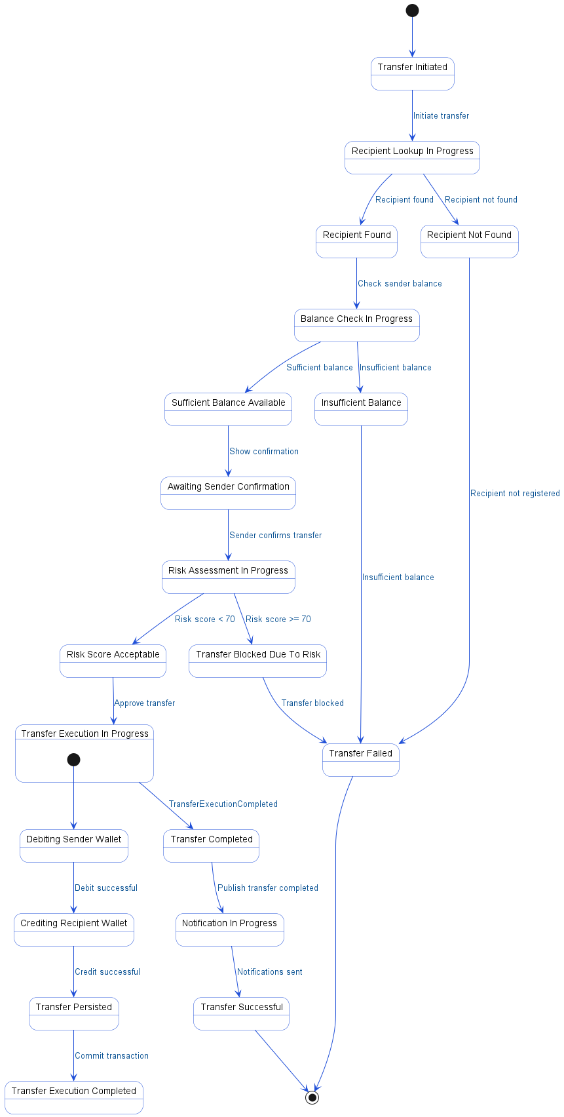

6.4. APIs Contract Agreement
# | Source | Destination | API | Protocol | Request Parameters | Response Parameters
1 | FinWallet App | API Gateway | POST /api/v1/transfers/p2p/init | REST |  | Show confirmation screen
2 | API Gateway | Transfer Service | initiateP2PTransfer | REST | senderId, recipientMobile, amount | {recipientName, amount, fees, total}
3 | Transfer Service | User Service | findUserByMobile | REST | recipientMobile | {recipientId, name, walletId}
4 | Transfer Service | Wallet Service | checkBalance | REST | senderWalletId | {available: 1500, sufficient: true}
5 | Wallet Service | Wallet Database | SELECT balance FROM wallets | JDBC |  | {balance: 1500}
6 | FinWallet App | API Gateway | POST /api/v1/transfers/p2p/confirm | REST |  | Transfer successful
7 | API Gateway | Transfer Service | confirmP2PTransfer | REST | transferId, pin | {status: SUCCESS, reference: TRF123456}
8 | Transfer Service | Fraud Detection | assessRisk | REST | senderId, recipientId, amount | {riskScore: 15, action: APPROVE}
9 | Transfer Service | Wallet Database | BEGIN TRANSACTION | JDBC
10 | Transfer Service | Wallet Service | debit | REST | senderWalletId, 500 | {success, txnId: TXN001}
11 | Wallet Service | Wallet Database | UPDATE wallets SET balance = balance - 500 | JDBC |  | {txnId: TXN001}
12 | Wallet Service | Wallet Database | INSERT transaction | JDBC | DEBIT | {txnId: TXN002}
13 | Transfer Service | Wallet Service | credit | REST | recipientWalletId, 500 | {success, txnId: TXN002}
14 | Wallet Service | Wallet Database | UPDATE wallets SET balance = balance + 500 | JDBC
15 | Wallet Service | Wallet Database | INSERT transaction | JDBC | CREDIT
16 | Transfer Service | Wallet Database | COMMIT TRANSACTION | JDBC
17 | Transfer Service | Event Bus | publish | REST | TransferCompleted
18 | Event Bus | Notification Service | consume | REST | TransferCompleted
19 | Notification Service | Sender | Push "Sent 500 SAR to Ahmed" | REST
20 | Transfer Service | Wallet Database | UPDATE transfer SET status = BLOCKED | JDBC
[*] Indicates that the data element is optional

6.5. Error Handling
# | Source | Destination | Scenario | Handling
1 | API Gateway | Transfer Service | initiateP2PTransfer  Timeout waiting for response from Transfer Service | Retry up to 3 times with exponential backoff; Log error with correlation ID for traceability; Return error code to upstream caller
2 | API Gateway | Transfer Service | initiateP2PTransfer  Transfer Service unavailable or returns 5xx error | Retry up to 3 times with exponential backoff; Log error with correlation ID for traceability; Activate circuit breaker, use fallback response
3 | Transfer Service | User Service | findUserByMobile  Timeout waiting for User Service response | Retry up to 3 times with exponential backoff; Log error with correlation ID for traceability; Return error code to upstream caller
4 | Transfer Service | User Service | findUserByMobile  User Service unavailable or returns 5xx error | Retry up to 3 times with exponential backoff; Log error with correlation ID for traceability; Activate circuit breaker, use fallback response
5 | Transfer Service | User Service | findUserByMobile  Recipient mobile number not found in User Service | Log error with correlation ID for traceability; Return error code to upstream caller
6 | Transfer Service | Wallet Service | checkBalance  Timeout waiting for Wallet Service response | Retry up to 3 times with exponential backoff; Log error with correlation ID for traceability; Return error code to upstream caller
7 | Transfer Service | Wallet Service | checkBalance  Wallet Service unavailable or returns 5xx error | Retry up to 3 times with exponential backoff; Log error with correlation ID for traceability; Activate circuit breaker, use fallback response
8 | API Gateway | Transfer Service | confirmP2PTransfer  Timeout waiting for response from Transfer Service | Retry up to 3 times with exponential backoff; Log error with correlation ID for traceability; Return error code to upstream caller
9 | API Gateway | Transfer Service | confirmP2PTransfer  Transfer Service unavailable or returns 5xx error | Retry up to 3 times with exponential backoff; Log error with correlation ID for traceability; Activate circuit breaker, use fallback response
10 | Transfer Service | Fraud Detection | assessRisk  Timeout waiting for Fraud Detection response | Retry up to 3 times with exponential backoff; Log error with correlation ID for traceability; Return error code to upstream caller
11 | Transfer Service | Fraud Detection | assessRisk  Fraud Detection unavailable or returns 5xx error | Retry up to 3 times with exponential backoff; Log error with correlation ID for traceability; Activate circuit breaker, use fallback response
12 | Transfer Service | Wallet Service | debit  Timeout waiting for Wallet Service response | Ensure idempotency to avoid duplicates on retry; Retry up to 3 times with exponential backoff; Log error with correlation ID for traceability; Return error code to upstream caller
13 | Transfer Service | Wallet Service | debit  Wallet Service unavailable or returns 5xx error | Ensure idempotency to avoid duplicates on retry; Retry up to 3 times with exponential backoff; Log error with correlation ID for traceability; Activate circuit breaker, use fallback response
14 | Transfer Service | Wallet Service | debit  Duplicate debit request due to retry after timeout | Ensure idempotency to avoid duplicates on retry; Log error with correlation ID for traceability; Return error code to upstream caller
15 | Transfer Service | Wallet Service | debit  Validation failure, insufficient balance to debit | Ensure idempotency to avoid duplicates on retry; Log error with correlation ID for traceability; Return error code to upstream caller
16 | Transfer Service | Wallet Service | credit  Timeout waiting for Wallet Service response | Ensure idempotency to avoid duplicates on retry; Retry up to 3 times with exponential backoff; Log error with correlation ID for traceability; Return error code to upstream caller
17 | Transfer Service | Wallet Service | credit  Wallet Service unavailable or returns 5xx error | Ensure idempotency to avoid duplicates on retry; Retry up to 3 times with exponential backoff; Log error with correlation ID for traceability; Activate circuit breaker, use fallback response
18 | Transfer Service | Wallet Service | credit  Duplicate credit request due to retry after timeout | Ensure idempotency to avoid duplicates on retry; Log error with correlation ID for traceability; Return error code to upstream caller
19 | Transfer Service | Wallet Service | credit  Validation failure, recipient wallet not found | Ensure idempotency to avoid duplicates on retry; Log error with correlation ID for traceability; Return error code to upstream caller
20 | Transfer Service | Event Bus | publish  Timeout publishing TransferCompleted event to Event Bus | Retry up to 3 times with exponential backoff; Log error with correlation ID for traceability; Queue request for asynchronous retry
21 | Transfer Service | Event Bus | publish  Event Bus unavailable or returns error on publish | Retry up to 3 times with exponential backoff; Log error with correlation ID for traceability; Queue request for asynchronous retry
22 | Event Bus | Notification Service | consume  Timeout waiting for Notification Service to consume event | Retry up to 3 times with exponential backoff; Log error with correlation ID for traceability; Notify operations team via alert if repeated
23 | Event Bus | Notification Service | consume  Notification Service unavailable or returns error on consume | Retry up to 3 times with exponential backoff; Log error with correlation ID for traceability; Notify operations team via alert if repeated

7. Bill Payment via SADAD

7.1. Sequence Diagram
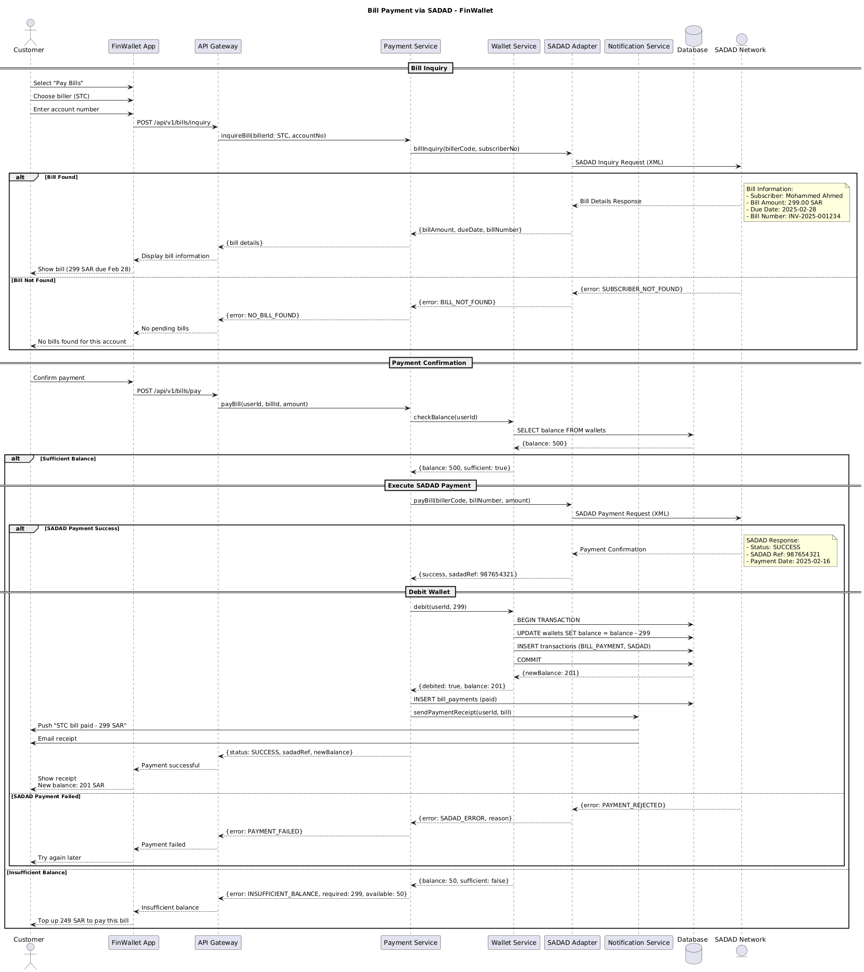

7.2. Flow Description
  - Overview
This flow describes the end-to-end process for bill payment via SADAD using the FinWallet platform. It covers bill inquiry, payment confirmation, interaction with the SADAD network, wallet debit, and user notification. The active participants in this flow are Customer, FinWallet App, API Gateway, Payment Service, Wallet Service, SADAD Adapter, Notification Service, Database, and SADAD Network. Each participant is responsible for specific interactions, validations, and data exchanges necessary to complete the bill payment process.
  - Process Flow
Bill Inquiry
The process begins when Customer selects the "Pay Bills" option in FinWallet App. Customer then chooses the biller, in this case STC, and enters the account number. FinWallet App sends a bill inquiry request to API Gateway using the endpoint POST /api/v1/bills/inquiry. API Gateway forwards this request to Payment Service by invoking the inquireBill operation with the biller ID and account number.
Payment Service initiates a bill inquiry by calling SADAD Adapter with the biller code and subscriber number. SADAD Adapter then sends a SADAD Inquiry Request in XML format to SADAD Network.
If SADAD Network finds a matching bill, it returns the bill details to SADAD Adapter.
Note: Bill Information:
- Subscriber: Mohammed Ahmed
- Bill Amount: 299.00 SAR
- Due Date: 2025-02-28
- Bill Number: INV-2025-001234
SADAD Adapter passes the bill amount, due date, and bill number to Payment Service. Payment Service returns the bill details to API Gateway, which instructs FinWallet App to display the bill information. FinWallet App then shows the bill details to Customer, indicating a 299 SAR payment due by February 28.
If SADAD Network does not find a bill for the provided account, it returns an error indicating the subscriber is not found. SADAD Adapter translates this to a bill not found error and sends it to Payment Service. Payment Service returns a no bill found error to API Gateway, which instructs FinWallet App to display that there are no pending bills. FinWallet App then informs Customer that no bills were found for the entered account.
Payment Confirmation
If a bill is found and displayed, Customer confirms the payment in FinWallet App. FinWallet App sends a payment request to API Gateway using POST /api/v1/bills/pay. API Gateway forwards this to Payment Service with the user ID, bill ID, and amount.
Payment Service checks the user's wallet balance by calling Wallet Service. Wallet Service queries Database for the wallet balance and receives the current balance.
If the balance is sufficient, Wallet Service returns the balance and a flag indicating sufficiency to Payment Service.
Execute SADAD Payment
Upon sufficient balance, Payment Service initiates the bill payment by calling SADAD Adapter with the biller code, bill number, and amount. SADAD Adapter sends a SADAD Payment Request in XML format to SADAD Network.
If the payment is successful, SADAD Network returns a payment confirmation to SADAD Adapter.
Note: SADAD Response:
- Status: SUCCESS
- SADAD Ref: 987654321
- Payment Date: 2025-02-16
SADAD Adapter passes the success status and SADAD reference to Payment Service.
Debit Wallet
Payment Service proceeds to debit the user's wallet by instructing Wallet Service to deduct 299 SAR. Wallet Service begins a transaction in Database, updates the wallet balance, inserts a transaction record for the bill payment via SADAD, and commits the transaction. Database returns the new balance to Wallet Service, which confirms the debit to Payment Service along with the updated balance.
Payment Service records the bill payment in Database. It then requests Notification Service to send a payment receipt to the user. Notification Service sends a push notification to Customer stating "STC bill paid - 299 SAR" and also emails the receipt.
Payment Service returns a success status, SADAD reference, and new balance to API Gateway. API Gateway notifies FinWallet App of the successful payment. FinWallet App displays the receipt and new balance (201 SAR) to Customer.
If the SADAD payment fails, SADAD Network returns a payment rejected error to SADAD Adapter. SADAD Adapter sends a SADAD error with the reason to Payment Service. Payment Service notifies API Gateway of the payment failure, which instructs FinWallet App to display a payment failure message. FinWallet App prompts Customer to try again later.
If the wallet balance is insufficient, Wallet Service returns the available balance and a flag indicating insufficiency to Payment Service. Payment Service notifies API Gateway of the insufficient balance, specifying the required and available amounts. API Gateway instructs FinWallet App to display an insufficient balance message. FinWallet App prompts Customer to top up 249 SAR to pay the bill.

7.3. State Machine Diagram
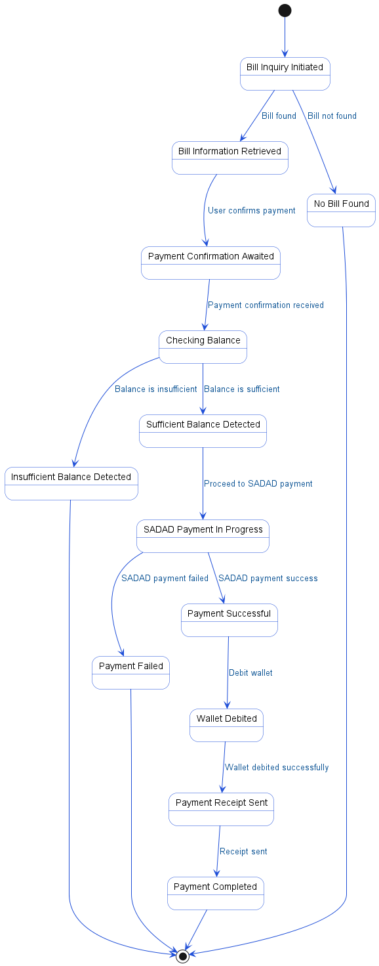

7.4. APIs Contract Agreement
# | Source | Destination | API | Protocol | Request Parameters | Response Parameters
1 | FinWallet App | API Gateway | POST /api/v1/bills/inquiry | REST |  | Display bill information
2 | API Gateway | Payment Service | inquireBill | REST | billerId: STC, accountNo | {bill details}
3 | Payment Service | SADAD Adapter | billInquiry | REST | billerCode, subscriberNo | {billAmount, dueDate, billNumber}
4 | SADAD Adapter | SADAD Network | SADAD Inquiry Request | REST | XML | Bill Details Response
5 | FinWallet App | API Gateway | POST /api/v1/bills/pay | REST |  | Payment successful
6 | API Gateway | Payment Service | payBill | REST | userId, billId, amount | {status: SUCCESS, sadadRef, newBalance}
7 | Payment Service | Wallet Service | checkBalance | REST | userId | {balance: 500, sufficient: true}
8 | Wallet Service | Database | SELECT balance FROM wallets | JDBC |  | {balance: 500}
9 | Payment Service | SADAD Adapter | payBill | REST | billerCode, billNumber, amount | {success, sadadRef: 987654321}
10 | SADAD Adapter | SADAD Network | SADAD Payment Request | REST | XML | Payment Confirmation
11 | Payment Service | Wallet Service | debit | REST | userId, 299 | {debited: true, balance: 201}
12 | Wallet Service | Database | BEGIN TRANSACTION | JDBC |  | {newBalance: 201}
13 | Wallet Service | Database | UPDATE wallets SET balance = balance - 299 | JDBC
14 | Wallet Service | Database | INSERT transactions | JDBC | BILL_PAYMENT, SADAD
15 | Wallet Service | Database | COMMIT | JDBC
16 | Payment Service | Database | INSERT bill_payments | JDBC | paid
17 | Payment Service | Notification Service | sendPaymentReceipt | REST | userId, bill
18 | Notification Service | Customer | Push "STC bill paid - 299 SAR" | REST
19 | Notification Service | Customer | Email receipt | REST
[*] Indicates that the data element is optional

7.5. Error Handling
# | Source | Destination | Scenario | Handling
1 | API Gateway | Payment Service | inquireBill  Timeout waiting for Payment Service response | Retry up to 3 times with exponential backoff; Log error with correlation ID for traceability; Return error code to upstream caller
2 | API Gateway | Payment Service | inquireBill  Payment Service unavailable | Retry up to 3 times with exponential backoff; Log error with correlation ID for traceability; Activate circuit breaker, use fallback response
3 | Payment Service | SADAD Adapter | billInquiry  Timeout waiting for SADAD Adapter response | Retry up to 3 times with exponential backoff; Log error with correlation ID for traceability; Return error code to upstream caller
4 | Payment Service | SADAD Adapter | billInquiry  SADAD Adapter unavailable | Retry up to 3 times with exponential backoff; Log error with correlation ID for traceability; Activate circuit breaker, use fallback response
5 | Payment Service | SADAD Adapter | billInquiry  Bill not found for given subscriber | Log error with correlation ID for traceability; Return error code to upstream caller
6 | API Gateway | Payment Service | payBill  Timeout waiting for Payment Service response | Retry up to 3 times with exponential backoff; Log error with correlation ID for traceability; Return error code to upstream caller
7 | API Gateway | Payment Service | payBill  Payment Service unavailable | Retry up to 3 times with exponential backoff; Log error with correlation ID for traceability; Activate circuit breaker, use fallback response
8 | Payment Service | Wallet Service | checkBalance  Timeout waiting for Wallet Service response | Retry up to 3 times with exponential backoff; Log error with correlation ID for traceability; Return error code to upstream caller
9 | Payment Service | Wallet Service | checkBalance  Wallet Service unavailable | Retry up to 3 times with exponential backoff; Log error with correlation ID for traceability; Activate circuit breaker, use fallback response
10 | Payment Service | SADAD Adapter | payBill  Timeout waiting for SADAD Adapter response | Ensure idempotency to avoid duplicates on retry; Retry up to 3 times with exponential backoff; Log error with correlation ID for traceability; Queue request for asynchronous retry
11 | Payment Service | SADAD Adapter | payBill  SADAD Adapter unavailable | Ensure idempotency to avoid duplicates on retry; Retry up to 3 times with exponential backoff; Log error with correlation ID for traceability; Queue request for asynchronous retry
12 | Payment Service | SADAD Adapter | payBill  Duplicate payment request sent | Ensure idempotency to avoid duplicates on retry; Log error with correlation ID for traceability; Return error code to upstream caller
13 | Payment Service | SADAD Adapter | payBill  SADAD payment rejected by network | Ensure idempotency to avoid duplicates on retry; Log error with correlation ID for traceability; Return error code to upstream caller
14 | Payment Service | Wallet Service | debit  Timeout waiting for Wallet Service response | Ensure idempotency to avoid duplicates on retry; Retry up to 3 times with exponential backoff; Log error with correlation ID for traceability; Queue request for asynchronous retry
15 | Payment Service | Wallet Service | debit  Wallet Service unavailable | Ensure idempotency to avoid duplicates on retry; Retry up to 3 times with exponential backoff; Log error with correlation ID for traceability; Queue request for asynchronous retry
16 | Payment Service | Wallet Service | debit  Duplicate debit request sent | Ensure idempotency to avoid duplicates on retry; Log error with correlation ID for traceability; Return error code to upstream caller
17 | Payment Service | Wallet Service | debit  Validation failure, insufficient wallet balance | Ensure idempotency to avoid duplicates on retry; Log error with correlation ID for traceability; Return error code to upstream caller
18 | Payment Service | Notification Service | sendPaymentReceipt  Timeout waiting for Notification Service response | Retry up to 3 times with exponential backoff; Log error with correlation ID for traceability; Queue request for asynchronous retry
19 | Payment Service | Notification Service | sendPaymentReceipt  Notification Service unavailable | Retry up to 3 times with exponential backoff; Log error with correlation ID for traceability; Queue request for asynchronous retry
20 | Payment Service | Notification Service | sendPaymentReceipt  Duplicate sendPaymentReceipt request sent | Log error with correlation ID for traceability; Return error code to upstream caller
21 | Payment Service | Notification Service | sendPaymentReceipt  Validation failure, invalid userId or bill data | Log error with correlation ID for traceability; Return error code to upstream caller

8. Appendix

8.1. User Registration and KYC Flow Data Elements
# | Service Name | Data Element | Description
1 | initiateRegistration (Request) | mobileNumber | Customer's mobile phone number for registration
2 | sendOTP (Request) | mobileNumber | Customer's mobile phone number for OTP delivery
3 | sendOTP (Request) | otp | One-Time Password generated for verification
4 | initiateRegistration (Response) | sessionId | Unique session identifier for registration flow
5 | initiateRegistration (Response) | otpSent | Indicates if OTP was successfully sent
6 | verifyOTP (Request) | sessionId | Unique session identifier for OTP verification
7 | verifyOTP (Request) | otp | One-Time Password entered by customer
8 | createUser (Request) | mobileNumber | Customer's mobile phone number for user creation
9 | createUser (Response) | userId | Unique identifier for the registered user
10 | createUser (Response) | status | Current user registration/KYC status
11 | verifyOTP (Response) | userId | Unique identifier for the registered user
12 | verifyOTP (Response) | token | Authentication token for session validation
13 | verifyOTP (Response) | status | Current user registration/KYC status
14 | verifyOTP (Response) | error | Error code returned on OTP verification failure
15 | submitPersonalInfo (Request) | userId | Unique identifier for the registered user
16 | submitPersonalInfo (Request) | data | User's personal details (name, DOB, address)
17 | submitPersonalInfo (Response) | status | Current KYC information submission status
18 | uploadDocument (Request) | userId | Unique identifier for the registered user
19 | uploadDocument (Request) | nationalId | National ID document image uploaded by user
20 | uploadDocument (Response) | documentId | Unique identifier for the uploaded document
21 | uploadDocument (Response) | extractedData | Data extracted from ID document (ID number, name, DOB, expiry)
22 | initiateVerification (Request) | userId | Unique identifier for the registered user
23 | verifyIdentity (Request) | idNumber | National ID number extracted from document
24 | verifyIdentity (Request) | dob | Date of birth from ID document
25 | verifyIdentity (Request) | name | Full name from ID document
26 | verifyIdentity (Response) | verified | Indicates if identity verification succeeded
27 | verifyIdentity (Response) | yakeen_ref | Reference code from Elm Yakeen verification
28 | verifyIdentity (Response) | reason | Reason for verification failure
29 | screenIndividual (Request) | name | Full name of individual for sanctions screening
30 | screenIndividual (Request) | dob | Date of birth of individual for screening
31 | screenIndividual (Request) | nationality | Nationality of individual for screening
32 | screenIndividual (Response) | clear | Indicates if individual cleared sanctions screening
33 | screenIndividual (Response) | score | Sanctions screening risk score
34 | screenIndividual (Response) | matches | List of potential sanctions matches found
35 | initiateVerification (Response) | status | Current KYC verification status
36 | initiateVerification (Response) | walletId | Unique identifier for the created wallet
37 | initiateVerification (Response) | reason | Reason for KYC rejection or failure

8.2. Wallet Top-up via Card Payment Data Elements
# | Service Name | Data Element | Description
1 | initiateTopup (Request) | userId | Unique identifier for the customer
2 | initiateTopup (Request) | amount | Transfer amount value
3 | initiateTopup (Request) | method | Payment method used for top-up (e.g., CARD)
4 | initiateTopup (Response) | topupId | Unique identifier for the top-up transaction
5 | initiateTopup (Response) | amount | Transfer amount value
6 | initiateTopup (Response) | paymentMethods | List of available payment methods for top-up
7 | initiateTopup (Response) | error | Error code or message if top-up initiation fails
8 | SELECT daily_topup FROM user_limits (Response) | dailyUsed | Amount already used for daily top-ups
9 | SELECT daily_topup FROM user_limits (Response) | limit | Maximum allowed daily top-up limit
10 | processCardPayment (Request) | topupId | Unique identifier for the top-up transaction
11 | processCardPayment (Request) | cardToken | Tokenized representation of the user's card
12 | preAuthCheck (Request) | userId | Unique identifier for the customer
13 | preAuthCheck (Request) | cardToken | Tokenized representation of the user's card
14 | preAuthCheck (Request) | amount | Transfer amount value
15 | preAuthCheck (Response) | approved | Indicates if transaction passed fraud check
16 | authorize (Request) | cardToken | Tokenized representation of the user's card
17 | authorize (Request) | amount | Transfer amount value
18 | authorize (Request) | currency | Currency code (e.g., SAR, USD)
19 | cardnetwork Authorization Response (Response) | status | Current transaction status (e.g., 3DS_REQUIRED)
20 | cardnetwork Authorization Response (Response) | acsUrl | URL for 3DS authentication challenge
21 | cardnetwork Authorization Response (Response) | pareq | Payment authentication request data for 3DS
22 | authorize (Response) | requires3DS | Indicates if 3DS authentication is required
23 | authorize (Response) | redirectUrl | URL to redirect user for 3DS authentication
24 | complete3DS (Request) | topupId | Unique identifier for the top-up transaction
25 | complete3DS (Request) | pares | 3DS authentication result/status
26 | capturePayment (Request) | authCode | Authorization code for payment capture
27 | cardnetwork Capture Response (Response) | captured | Indicates if payment was successfully captured
28 | cardnetwork Capture Response (Response) | rrn | Retrieval reference number for the transaction
29 | capturePayment (Response) | success | Indicates if payment capture was successful
30 | capturePayment (Response) | reference | Reference identifier for the captured payment
31 | creditWallet (Request) | userId | Unique identifier for the customer
32 | creditWallet (Request) | amount | Transfer amount value
33 | creditWallet (Response) | credited | Indicates if wallet was credited successfully
34 | creditWallet (Response) | balance | Customer's updated wallet balance
35 | sendTopupConfirmation (Request) | userId | Unique identifier for the customer
36 | sendTopupConfirmation (Request) | amount | Transfer amount value
37 | payment (Final Response) | status | Current transaction status (e.g., SUCCESS)
38 | payment (Final Response) | balance | Customer's updated wallet balance
39 | payment (Error Response) | error | Error code or message if transaction fails
40 | 3DS Callback (Request) | pares | 3DS authentication result/status
41 | 3DS Callback (Request) | topupId | Unique identifier for the top-up transaction

8.3. Peer-to-Peer Fund Transfer Data Elements
# | Service Name | Data Element | Description
1 | initiateP2PTransfer (Request) | senderId | Unique identifier of the sender
2 | initiateP2PTransfer (Request) | recipientMobile | Recipient's mobile phone number
3 | initiateP2PTransfer (Request) | amount | Transfer amount value
4 | findUserByMobile (Request) | recipientMobile | Recipient's mobile phone number
5 | findUserByMobile (Response) | recipientId | Unique identifier of the recipient
6 | findUserByMobile (Response) | name | Recipient's full name
7 | findUserByMobile (Response) | walletId | Recipient's wallet identifier
8 | findUserByMobile (Response) | error | Error code returned on failure
9 | checkBalance (Request) | senderWalletId | Sender's wallet identifier
10 | checkBalance (Response) | balance | Current wallet balance
11 | checkBalance (Response) | available | Available wallet balance
12 | checkBalance (Response) | sufficient | Indicates if balance is sufficient for transaction
13 | calculateFees (Request) | amount | Transfer amount value
14 | calculateFees (Request) | type | Type of transfer (e.g., P2P)
15 | initiateP2PTransfer (Response)  confirmP2PTransfer (Request)  assessRisk (Request)  assessRisk (Response)  debit (Request)  debit (Response)  credit (Request)  credit (Response)  publish (Request)  consume (Request) | recipientName | Recipient's full name
16 |  | amount | Transfer amount value
17 |  | fees | Service fee amount charged
18 |  | total | Total amount including fees
19 |  | error | Error code returned on failure
20 |  | transferId | Unique identifier for the transfer
21 |  | pin | Personal Identification Number for authorization
22 |  | senderId | Unique identifier of the sender
23 |  | recipientId | Unique identifier of the recipient
24 |  | amount | Transfer amount value
25 |  | riskScore | Calculated risk score for the transaction
26 |  | action | Action to take based on risk assessment
27 |  | senderWalletId | Sender's wallet identifier
28 |  | 500 | Transfer amount value
29 |  | success | Indicates if debit operation was successful
30 |  | txnId | Unique identifier for the debit transaction
31 |  | recipientWalletId | Recipient's wallet identifier
32 |  | 500 | Transfer amount value
33 |  | success | Indicates if credit operation was successful
34 |  | txnId | Unique identifier for the credit transaction
35 |  | TransferCompleted | Event indicating transfer completion
36 |  | TransferCompleted | Event indicating transfer completion
37 |  | error | Error code returned on failure
38 |  | reason | Descriptive error message
39 | confirmP2PTransfer (Response) | status | Current transaction status
40 | confirmP2PTransfer (Response) | reference | Unique reference number for the transfer
41 | confirmP2PTransfer (Response) | error | Error code returned on failure
42 | confirmP2PTransfer (Response) | reason | Descriptive error message

8.4. Bill Payment via SADAD Data Elements
# | Service Name | Data Element | Description
1 | inquireBill (Request) | billerId | Unique identifier for the selected biller (e.g., STC)
2 | inquireBill (Request) | accountNo | Customer's bill account number for inquiry
3 | billInquiry (Request) | billerCode | Code representing the biller in SADAD system
4 | billInquiry (Request) | subscriberNo | Subscriber/account number for bill inquiry
5 | billInquiry (Response) | billAmount | Amount due for the bill
6 | billInquiry (Response) | dueDate | Bill payment due date
7 | billInquiry (Response) | billNumber | Unique identifier for the bill
8 | billInquiry (Response) | error | Error code or message for inquiry failure
9 | payBill (Request) | userId | Unique identifier for the customer in FinWallet
10 | payBill (Request) | billId | Unique identifier for the bill to be paid
11 | payBill (Request) | amount | Amount to be paid for the bill
12 | checkBalance (Request) | userId | Unique identifier for the customer in FinWallet
13 | checkBalance (Response) | balance | Current wallet balance for the user
14 | checkBalance (Response) | sufficient | Indicates if wallet balance is sufficient for payment
15 | payBill (Request) [SADAD Adapter] | billerCode | Code representing the biller in SADAD system
16 | payBill (Request) [SADAD Adapter] | billNumber | Unique identifier for the bill
17 | payBill (Request) [SADAD Adapter] | amount | Amount to be paid for the bill
18 | payBill (Response) [SADAD Adapter] | success | Indicates if the payment was successful
19 | payBill (Response) [SADAD Adapter] | sadadRef | Reference number provided by SADAD for the payment
20 | debit (Request) | userId | Unique identifier for the customer in FinWallet
21 | debit (Request) | 299 | Amount to be debited from the wallet (hardcoded in flow)
22 | debit (Response) | debited | Indicates if the wallet was successfully debited
23 | debit (Response) | balance | Updated wallet balance after debit
24 | debit (Response) [Database] | newBalance | New wallet balance after transaction
25 | sendPaymentReceipt (Request) | userId | Unique identifier for the customer in FinWallet
26 | sendPaymentReceipt (Request) | bill | Bill information for the payment receipt
27 | payBill (Response) | status | Current transaction status
28 | payBill (Response) | sadadRef | Reference number provided by SADAD for the payment
29 | payBill (Response) | newBalance | Updated wallet balance after bill payment
30 | payBill (Response) | error | Error code or message for payment failure
31 | payBill (Response) | reason | Reason for payment failure
32 | payBill (Response) | required | Amount required to complete the payment
33 | payBill (Response) | available | Available wallet balance for the user

8.5. Solution Architecture Reference Documents
# | Name | File
1 | BRD | Refer to Latest BRD Attached to JIRA Ticket

